Earth Day at Alewife

Friends of Alewife Reservation 4th Annual Mystic River Cleanup
Volunteers Needed

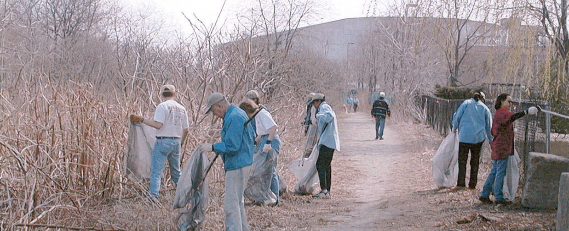
Saturday May 1, 2004 10 am to 2 pm

Wear old clothes suitable for rough terrain
Tools, gloves, trash bags, drinking water, oranges, and power bars provided

Meet at Passenger Drop-off Area behind Alewife MBTA Station (end of Red Line)

(Sign-in table will be next to rotary parking garage)
This is a test of the program
Cars park at Dodge Co., 165 Cambridge Park Drive

SPONSORS: Hillside Gardens, Spaulding and Slye, Zeff Photo, MWH Inc., Dodge Co., Turf Equipment, Wyeth Co., Bulfinch Co.
Department of Conservation Recreation, City of Cambridge
In Conjunction with Mystic River Watershed Association Super Mystic cleanup project throughout the watershed.

For more information: www.friendsofalewifereservation.org
Call Dennis at 617 314-7102

