Migrant and Breeding Bird Survey
2002
******************
Alewife Reservation
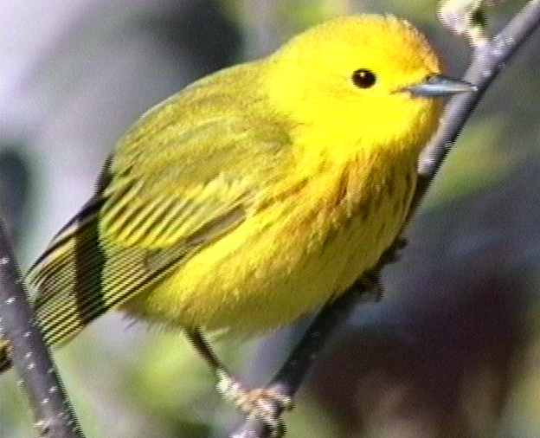

The Friends of Alewife Reservation

Conducted by: David Brown’s Wildlife Services
Carlisle, Mass.

Funded by: The Riverways Small Grants Program
Massachusetts Department of Fisheries, Wildlife and
Environmental Law Enforcement

Table Of Contents

- The Survey

Total species list…………………………..……………………..page 1

Winter visitors………………………………..………………….page 4

Visitors during breeding season…………………………………page 4

Breeding birds………………………….………………………..page 5

Discussion by order…………………………..………………….page 6

- Evaluation

Description of the land…………………..…………….………...page 9

General assessment………………………………..…………….page 11

Causes for concern………………...…………………………….page 11

Significant habitats………………………………..……………..page 13

Management recommendations……………………..…………...page 15

Wildlife education……………………………………………….page 15

Appendices

- Cumulative species list and charts
- Interpretive commentary
- Habitat map of Alewife Reservation
- Cavity users
- Nest boxes

Alewife Bird Survey-2002

Background
During the winter of 2001-2 a grant proposal was submitted by the Friends of Alewife Reservation to the Riverways Small Grants Program of the Massachusetts Department of Fisheries, Wildlife and Environmental Law Enforcement to conduct two wildlife inventories in the park, a mammal tracking inventory and a combined migrant and breeding bird survey. The inventories were conducted by David Brown of David Brown’s Wildlife Services, Carlisle, Mass., during the late winter and spring of 2002.
The intent of the surveys was to update information about wildlife populations in the reservation. This information could then be used to evaluate the continuing suitability of the park as an urban wildlife resource, to increase public awareness of the presence of wildlife in an urban area, to inform advocacy for the park and to provide information for advising the Metropolitan District Commission with respect to its management of the resource. Two separate reports have been prepared, one for mammals and one for birds. As each report is intended to stand alone, some information with appropriate modification appears in both studies.

Part I. The Survey

Because funding limitations did not permit separate migrant and breeding bird inventories, it was decided to combine the two into a single study. Whatever the results might lack in completeness, they were expected to provide a sufficiently good view of the bird populations that both reside in the park or otherwise use it as a resource. A total of 89 species of birds were observed in the reservation from late February through June. That total list is presented below, followed by separate tables for winter visitors, visiting species during the breeding season and finally breeding birds.

A. Total species list
The following table shows all of 90 species found during the survey. It is ordered according to the evolutionary progression method used in most field guides.

1. Status Codes:
“C”: “Common” describes any bird found on the reservation three or more times in different locations.
“U”: “Uncommon” is used for any species found only once or twice, any second observation occurring at a different location from the first.
“M”: “Migrant” indicates any species found only to be passing through during spring migration.
“W”: “Winter” describes any species present either as a resident or visitor during late winter, when the inventory began, but not during breeding season.
“B”: “Breeding” indicates any species showing territoriality during breeding season.
“V”: “Visitor” describes any species present during breeding season but not believed to be nesting on the reservation. Such a species may be present at other seasons as well.

2. Numbers:
The numbers under Observations correspond to the numbers in the Cumulative Observations list in Appendix A as well as to the circled numbers on the charts included in that appendix. The numbers under Commentary correspond to those same listings and charts as well as to comments in the Interpretive Commentary in Appendix B.

Species Status Observation # Commentary #
Double-crested cormorant  Great blue heron  Black-crowned night heron  Mute swan  Canada goose  Mallard  Black Duck  Green-winged teal  Northern shoveller  Wood duck  Hooded merganser  Common merganser  Sharp-shinned hawk  Red-tailed hawk  Merlin  American kestrel  Ring-necked pheasant  Killdeer  Solitary sandpiper  American woodcock  Least sandpiper  Herring gull  Greater black-backed gull  Ring-billed gull  Rock dove  Nighthawk  Chimney swift  Mourning dove  Belted kingfisher  Common flicker  Hairy woodpecker  Downy woodpecker  Eastern kingbird  Eastern phoebe  Willow flycatcher  Least flycatcher  Tree swallow  Rough-winged swallow  Blue jay  American crow  Black-capped chickadee  Tufted titmouse  White-breasted nuthatch  Brown creeper  House wren  Carolina wren  Northern mockingbird  Gray catbird  American robin  Wood thrush  Ruby-crowned kinglet  Cedar waxwing  European starling  White-eyed vireo  Red-eyed vireo  Warbling vireo  Black and white warbler  Northern parula  Yellow warbler  Wilson's warbler  Magnolia warbler  Black-throated blue warbler  Myrtle warbler  Black-throated green warbler  Blackburnian warbler  Chestnut-sided warbler  Blackpoll warbler  Prairie warbler  Palm warbler  Northern waterthrush  Common yellowthroat  Canada warbler  American redstart  House sparrow  Red-winged blackbird  Baltimore oriole  Common grackle  Brown-headed cowbird  Northern cardinal  Indigo bunting  House finch  Common redpoll  American goldfinch  Savannah sparrow  Northern junco  Field sparrow  White-throated sparrow  Lincoln's sparrow  Swamp sparrow  Song sparrow | cv  cv  cv  uv  cb  cb  uw  uw  cw  ub  uw  uw  um  cv  um  um  cb  ub  um  cb  um  cv  uv  uw  cb  cv  cv  cb  cv  cb  uv  cb  cb  cb  ub  um  cb  um  cb  cv  cb  cb  cb  cb  cb  ub  cb  cb  cb  ub  um  cb  cb  um  ub  cb  cb  cm  cb  um  cm  cm  cm  um  um  cm  um  um  cm  cm  cb  um  cm  cb  cb  cb  cb  cb  cb  um  cb  uw  cb  um  cw  um  cw  um  ub  cb | 132  8, 13  39, 43, 44, 49, 77  8, 13, 133, 144  40  79  6  1, 11, 29, 37  7, 12, 30  24, 32, 36, 145, 151  31  5  17  2, 38  35  27, 28, 46, 50, 53  9, 48  72, 78  18, 19, 20, 21, 22, 23, 25, 26  96  4  41  45  124, 125, 146, 147  105  87  98  86  42, 60, 71, 106, 150  119  85  139  95  143, 149  69, 93, 123, 128, 136, 138  83, 99  73, 74, 108, 113, 121  61, 66, 68, 70, 80, 118, 142  109  100, 107, 111, 114  82, 120  54, 58, 62, 63, 67  65, 94  90  130, 137  134  115  52, 57, 64, 88  81, 101, 110, 112  75, 84, 91, 97, 141  126, 135  104, 117, 122, 127  33, 129  76, 140  34  131  3  10  56  148  14, 51, 55, 59  102, 103 | 39  133, 144  1, 29  7, 12  32, 145, 151  31  17  2  35  27, 28, 53  48  72, 78  18-26  41  45  124, 125, 146, 147  86  42, 60, 71  119  85  139  95  143  69  73, 74  82  54  65  134  115  52  81  75, 84  126,135  122  33  76  34  131  3  14, 51

B. Winter visitors
The following listing filters the data in Figure 1 for those species present at one time or another in the winter but not at other seasons.
Although the bird survey was not begun until late February, enough of the winter was left to suggest seasonal visitors. Due to the abnormally warm winter, neither the river nor ponds froze over, allowing use by waterfowl and herons. In addition, one flock of redpolls, visitors from the far North, was observed in riverside alders.

Species Status Observation # Commentary #
Black Duck  Green-winged teal  Northern shoveller  Hooded merganser  Common merganser  Ring-billed gull  Common redpoll  Northern junco  White-throated sparrow | uw  uw  cw  uw  uw  uw  uw  cw  cw | 6  1, 11, 29, 37  7, 12, 30  31  5  4  3  14, 51, 55, 59 | 1, 29  7, 12  31  3  14, 51

C. Visitors during breeding season
Several species of birds were present during breeding season but are believed to be nesting off-property and visiting the reservation to feed. Great blue herons and black-crowned night herons fall into this category, as do red-tailed hawks.

Species Status Observation # Commentary #
Double-crested cormorant  Great blue heron  Black-crowned night heron  Mute swan  Red-tailed hawk  Herring gull  Greater black-backed gull  Nighthawk  Chimney swift  Belted kingfisher  Hairy woodpecker  American crow | cv  cv  cv  uv  cv  cv  uv  cv  cv  cv  uv  cv | 132  8, 13  39, 43, 44, 49, 77  8, 13, 133, 144  2, 38  41 | 39  133, 144  2  41

D. Breeding Birds
For purposes of the survey a singing or otherwise displaying male of any species located in early June was regarded as sufficient evidence of at least an attempt to breed. If there was any suspicion that the bird was a late migrant, the territory was checked twice to insure that the male was resident. In the case of early nesters where the males may have ceased displaying by early June (e.g. woodcock), earlier evidence of repeated singing or displaying at the same location was also taken as evidence of territoriality and an attempt to breed. A total of 40 species satisfied these criteria and are listed below.

Species Status Observation # Commentary #
Canada goose  Mallard  Ring-necked pheasant  Killdeer  American woodcock  Rock dove  Mourning dove  Common flicker  Downy woodpecker  Eastern kingbird  Eastern phoebe  Willow flycatcher  Tree swallow  Blue jay  Black-capped chickadee  Tufted titmouse  White-breasted nuthatch  Brown creeper  House wren  Carolina wren  Northern mockingbird  Gray catbird  American robin  Wood thrush  Cedar waxwing  European starling  Warbling vireo  Black and white warbler  Yellow warbler  Common yellowthroat  House sparrow  Red-winged blackbird  Baltimore oriole  Common grackle  Brown-headed cowbird  Northern cardinal  House finch  American goldfinch  Swamp sparrow  Song sparrow | cb  cb  cb  ub  cb  cb  cb  cb  cb  cb  cb  ub  cb  cb  cb  cb  cb  cb  cb  ub  cb  cb  cb  ub  cb  cb  cb  cb  cb  cb  cb  cb  cb  cb  cb  cb  cb  cb  ub  cb | 40  79  27, 28, 46, 50, 53  9, 48  18, 19, 20, 21, 22, 23, 25, 26  124, 125, 146, 147  87  86  42, 60, 71, 106, 150  119  139  69, 93, 123, 128, 136, 138  83, 99  61, 66, 68, 70, 80, 118, 142  75, 84, 91, 97, 141  33, 129  76, 140  34  10  102, 103 | 27, 28, 53  48  18-26  45  124, 125, 146, 147  86  42, 60, 71  119  139  69  75, 84  33  76  34

E. Discussion by order

Cormorants: At least five double-crested cormorants were persistent visitors to Little Pond in the late spring. One was an adult, the rest immature birds.
Herons: Both great blue and black-crowned night herons were common, especially at the outlet of Little River from Little Pond. No bitterns were detected during the survey.
Waterfowl: 20-30 Canada geese were resident in Little Pond and the river through late winter and into the spring. Most of these were probably non-breeding immature birds. Only two broods of goslings were seen, and those quite small in number. The only other successful breeder appears to be mallard ducks. Two wood ducks were seen flying downriver late in the spring, and what was probably the same pair was seen shortly thereafter in Little Pond at a point when they should have had ducklings if they had been successful at nesting. Given the warm winter, several other species of birds were regular visitors to Little Pond, including two species of merganser, black ducks and as many as nine northern shovellers. A pair of gree-winged teal were persistent at Blair Pond and the river.
Hawks and falcons: A very tame immature red-tailed hawk hunted both sides of the river from late winter into the spring, preying on small rodents in the open areas. All other hawks and falcons observed during the survey were migrants.
Rails: Despite the existence of several small cattail marshes in the reservation, no rails such as Virginias and Soras, present elsewhere in eastern Massachusetts in such habitat, were heard during the survey.
Sandpipers: Two solitary sandpipers and a lone least sandpiper were observed probing the mud bars in both Blair and Perch Pond. It is likely that spotted sandpipers also visit from time to time.
Gulls: Herring gulls were common visitors to Little Pond. One ring-billed gull was also observed during late winter, and a single greater black-backed was observed in late spring, both on the same pond.
Pigeons and doves: Many “rock doves”, as the feral domestic pigeon is called, roosted regularly under the bridge on the Alewife T access road. Mourning doves were common throughout the more open areas of the park.
Owls: Although a great horned owls was reported in the past and may still visit to hunt the small fields at night, none of this species, increasingly common in suburbia, was heard in the park. Few suitable day roosts exist where they can keep out of the wind and conceal themselves from harassing crows. Although there is habitat for screech owls, none were heard. Lack of nest holes probably accounts for this.
Goatsuckers: Nighthawks sometimes nest on the gravel roofs of 3-deckers and hunt flying insects at night over Cambridge. These birds are not hawks, at all, but relatives of whip-poor-wills, getting their name from the habit of “hawking” insects, or capturing them on the wing.
Swifts: Chimney swifts commonly overfly Cambridge during the day, catching flying insects. At night their place is taken by bats while the swifts roost inside the chimneys of some of the older buildings in the area, like the Harvard Smithsonian Observatory. Several were seen flying after insects over Little Pond in late spring.
Kingfishers: Belted kingfishers were observed in late winter and early spring hunting the waters in the park. Another was seen in mid-June over Blair Pond. Apparently a dirt bank used by the birds for breeding was removed and may have discouraged them from nesting in the park.
Woodpeckers: Flickers were heard late winter into spring at the west end of the park around Perch Pond. One hairy woodpecker was seen in very early spring and downies were common throughout the treed areas of the park.
Flycatchers: At least two pairs of very conspicuous kingbirds hunted the river. One pair of phoebes nested at the culvert on Wellington Brook and others probably nested elsewhere. Two singing male willow flycatchers were persistent in the park, one at mid-river and the other at the west end.
Swallows: Tree swallows were common over the waters of the park, while one pair of the less common rough-winged swallow was observed at Blair Pond before nesting season.
Corvids: The calls of common crows were heard constantly in the park. No alarm such as would occur at intrusion of nesting area occurred during the survey, however, suggesting that these birds are breeding off-property. Blue jays were quite common as well in the park.
Titmice, nuthatches and creepers: Black-capped chickadees were quite common in the treed areas of the park throughout the survey. Tufted titmice were less common and white-breasted nuthatches less common yet. Several brown creepers were seen and heard, especially in the early spring.
Wrens: House wrens were singing on both sides of the bikepath in the early spring. Carolina wrens, a species that has been slowly spreading northward, took advantage of the warm winter to extend their range into the Boston area and beyond. Singing males were detected in three separate locations, including one in late spring, suggesting an effort to nest.
Mimic thrushes: Mockingbirds appeared to be nesting in the ornamental shrubbery at the Hill Estates and foraging into the park. Catbirds were abundant in river- and brookside thickets all along the river.
Thrushes: Robins were abundant in late winter and into breeding season, apparently surviving during the colder months on the abundant sumac berries that the park affords. At least one wood thrush was heard singing on territory on both sides of Acorn Park Drive in the Belmont Upland. No hermit thrushes were detected, however. These last prefer a mix of conifer and deciduous trees, the former largely lacking in the reservation.
Kinglets: Only a couple of migrant ruby-crowned kinglets were found in very early to mid-spring, hover-feeding on early insect hatches. Golden-crowned kinglets, which are common winter visitors from the North, were not detected.
Waxwings: Cedar waxwings are very good flycatchers that also like to feed on apple blossoms in the spring. They were first detected in late spring, feeding by the former method near the Little River. Their presence was persistent into late spring. As they are late nesters, it cannot be said for sure that they will breed in the park but this is likely.
Starlings: This introduced species was all too common in the park. Starlings nest very early in cavities, denying these scarce sites to native species.
Vireos: Warbling vireos were singing on territory in several locations in the reservation. Red-eyed vireos arrived rather late with one male singing persistently in large trees near the river at the east end of the park. One singing white-eyed vireo was heard northeast of Perch Pond in suitable nesting habitat for this species; however, it was not heard or seen again.
Wood warblers: Eighteen species of these colorful little migrants were observed in the reservation during the spring. Yellow warblers and common yellowthroats were abundant, their songs being heard in the thickets all along the water system in the park. A Canada warbler was heard twice at the same location at the west end of the park a week apart, suggesting an attempt to breed. The habitat is suitable for this species, but the bird has not been heard since. This does not necessarily mean that the bird is no longer present. Many birds become secretive during the incubation period, singing only when feeling territorial pressure from another male of the same species. As this was the only Canada warbler detected in the survey, it and a mate could be present but with the male maintaining silence. Nevertheless, without additional evidence of presence late in the period, it is classified as an uncommon migrant in the survey.
Blackbirds: Red-winged blackbirds arrived in numbers in March and inhabited every patch of cattail marsh in the park. Common grackles were indeed common in the reservation and cowbirds arrived at the same time as the red wings. These last are nest parasitizers: having adapted eons ago to a nomadic existence following bison herds, they regularly victimize other birds by laying eggs in their nests. Yellow warblers, abundant in the park, are likely foster parents for many cowbird chicks.
Finches: Cardinals were common in the thickets all along the water system in the park in winter as well as spring. This species was rare and local in Massachusetts forty years ago but has spread northward with help of bird feeders, the metropolitan heat island and suburban shrubbery. One flock of common redpolls, visitors from the far North, was observed descending on an alder thicket at mid-river in late winter. A single male indigo bunting sang from an aspen edge in late spring but was not heard again. House finches, a native American bird that was introduced to the east coast from the West, were common near the bikepath, a pair nesting in the air-conditioning plant for the newer Wyeth Building.
Song sparrows were abundant in the brushy wetlands of the park, while house sparrows, a noxious alien species, were common near the bikepath. A number of white-throated sparrows appeared to have overwintered in the park, pushing on with the arrival of spring. Of note was one migrating Lincoln’s sparrow that was located foraging on the ground near Wellington Brook at mid-spring.

Part II. Evaluation

A. Description of the land: topography and vegetation. (Please refer to the Habitat Map in Appendix C.)
Alewife Reservation is an urban wild surrounded by industry, heavy-use roadways, office parks and human residences. It is located in the Boston basin, an area that in its geologic history apparently sank under the weight of glacial ice and thereafter accumulated a fine silt that settled out as the final product of outwash from inland glaciers just before their meltwater entered the ocean. Where this silt is saturated by the aquifer, it forms an underlay of clay. Since the end of the last glacial period, however, the area has also been subject to alluvial influence with deposition from periodic flooding that leached out minerals from inland and upland locations, depositing them in a rich black soil over the clay underlay.
Today Alewife Reservation is for the most part floodplain for Little River and Alewife Brook. Historically part of a large marsh abutting Fresh Pond, the area has been progressively filled for development, so that today there is little terrain in the park that has not been disturbed. The Little River, which drains Little Pond, itself fed by Winn Brook and Spy Pond, receives inflow from Blair Pond via Wellington Brook, as well as from a number of sewer discharge conduits. The river was relocated from its meandering natural course and straightened into a channel with steep banks, apparently to prevent flooding and to better serve as a conduit for runoff and sewerage into the Mystic River downstream and ultimately into the ocean. At the east end of the park, Alewife Brook enters the river via a ditch from a culvert at the edge of the park’s boundary near the T-station.
Relocation and channeling of the river in the past has reduced the frequency of flooding but the vegetation types found in the park still reflect a history of periodic inundation. Specifically, the dominant forest type is composed of floodplain species such as silver maple and black willow as well as red maple, all species that can survive total saturation of the soil in which they grow.
A high burm, which at one time elevated a railroad track, runs along the south boundary of the reservation. This burm currently supports a dirt bicycle path as well as some of the few non-floodplain trees present in the reservation, specifically several medium-age scarlet oaks. One large red oak grows in the northwest section of the park, called the “Belmont Uplands” and a number of planted pin oaks, a species not native to this area of New England, line the former Arthur D. Little property on the north bank of the Little River in the middle of the reservation. Otherwise the occurrence of mature oaks in the parks is quite spotty.
Many cherry trees are scattered around the park, including one substantial stand of black cherry in the woods near the northeast shore of Little Pond. These were probably escapes from homesteading in earlier times since these trees, valued as furniture wood and for tool handles, were often planted around residences as a money crop.
Apple trees are also frequently found in the park, mostly at its western end, apparently relict from an orchard that existed in the area many years ago. As these trees are no longer cultivated, they are not sprayed, creating an attractant to insects and to the birds that feed on them.
Aspen, or “poplar” as the two native species are called in New England, are found in several areas of the park. The most extensive stand is at the eastern end of the reservation south of the river. However another small grove exists south of Perch Pond and a third at the northwest corner of Yates Pond, with many individual trees scattered around the park. These trees are regarded as successional, creating shade under which they themselves cannot reproduce and thus preparing the way for more shade tolerant species to follow. The presence of two pure stands in the floodplain is probably a function of the frustration of natural periodic flooding of the area, a factor that has allowed this species to make advances in the more open areas of the park, especially at its eastern end. The recent residence of beavers in the park has resulted in cutting of many of these trees, a favorite feed species for these large rodents. It is possible that this feeding activity may stabilize the aspen groves so that the successional process is short-circuited, ironically perpetuating the presence of aspen groves in the park.
Many other species of trees are present in small numbers on the reservation. Norway maples and boxelders, neither native to the region, are probably escapes from the cultivated trees planted along city streets to replace the elms that were devastated by the Dutch elm blight. A number of fairly mature ashes can also be found scattered around the floodplain.
Interestingly, few conifers exist in the park. The only ones that are present were planted as landscaping on the property of abutters and are so scarce that they do not serve as a significant habitat for species that prefer this forest type. In winter great horned owls, the most common suburban owl, depend on dense conifers for roosting sites, out of the wind and concealed from harassing crows. Lack of such trees means that these owls must visit from other areas in order to prey on the abundant rabbit and vole populations in the park’s fields.
At most, the western sections of the park can be described as open woodland; nowhere except in the extreme northwest portion is there anything like a closed canopy. The eastern section is more open and marshy, with the exception of the near-monoculture of aspens in one extensive grove.
In the more wooded sections of the park undergrowth varies with sunlight at the surface. Under the silver maples in the northwest section there is relatively little, with bare alluvial soil visible under dead leaf cover. In more open woodlands in the western part, are a variety of bushy species like honeysuckle, with shrub dogwoods and European buckthorn, an invasive, proliferating along the river. Pussy willows and alder grow in the marshy areas at mid-river. Sumac genets are very common everywhere in the park, in some places amounting to monocultural growth with individuals occasionally growing to the stature of trees.
Many small cattail marshes exist especially in the wet impoundments on both sides of Little River in the middle of the park. However, another exists along the northeast shore of Little Pond and a third at the west margin of Yates Pond. All these marshes are under siege by invasives, particularly purple loosestrife. Pure stands of giant reed (fragmites) and Japanese knotweed are spreading in the bottomlands, with latter concentrated at the east end of the park and along the burm south of the river.

B. General assessment
The area surrounding Alewife Brook has been visited by birders and other naturalists since at least the days of William Brewster, the first ornithologist in the history of the Commonwealth. In his day the area was a large marsh and swamp associated with Fresh Pond to the south. Since then the area has been cut over, carved away and filled for industry and residence, a process that continues to this day. In addition the waterways have been altered so that Alewife Brook has been reduced to a ditch emerging from a culvert and running only a couple of hundred yards before entering the Little River, itself rechannelled from its natural meandering course where it once flooded an extensive wetland. The reservation proper is only 115 acres, but abutting private property on the northwest side of the park, still in more or less natural condition, increases the size of the “greater Alewife natural area” by another 25 acres or so.
Despite the small size of the park the survey found Alewife Reservation and its abutting natural acreage to be a vibrant and valuable bird resource with a total of 89 species noted during late winter, spring and early summer. Anecdotal and published reports put the total number of species possible in the reservation even higher. It is likely that persistent observation year-round would push the total number of species, resident and migrating, to well over 100.
The reservation’s attractiveness to birds results from both its variety of habitats, described above, as well as its location. In spring (and presumably in fall as well) migrant birds passing in the night over the relentlessly urbanized Boston/Cambridge area need somewhere to stop, with habitat that will permit them to rest, feed and replenish energy before moving on. Hence the well-known concentration of bird life at local cemeteries like Mt. Auburn. The varied habitats of Alewife, large trees, swamp, brushy borders, fields, wetlands, river and pond provide a useful stop-over for a correspondingly diverse selection of migrant species. Alewife’s wildness, as opposed to more cultivated and urbanized parks and cemeteries, makes it especially useful for this purpose.
Since Alewife has no extensive forest, it is not surprising that canopy species like scarlet tanagers and wood pewees were not recorded during the survey. Nor were ovenbirds or hermit thrushes found, ground-nesting species that seems to require extensive woodlands with little intrusion by dogs. In former times when there were more extensive woodlands with mixed composition, all these species would probably have been present. Instead, Alewife supports bird species that favor more open, brushy and wet habitats.

C. Causes for concern
1. Feral cats. At least four apparently feral cats currently hunt the park south of Little River. To a certain extent they mimic natural predation in the absence of bobcats. However, the fact that two were seen consorting suggests a colonial situation in which they can become numerous, resulting in a serious effect on ground nesting birds like woodcock. Hopefully the recently arrived coyote(s) may have some effect on the feral cat population. The sign of coyote was limited to north of the river while feral cats were on the south side, either as a function of coyote presence or the relative isolation of the north side, or both. If coyote predation does not control cat numbers, active measures may be needed.
2. Carp. An abundant population of carp was observed in Little Pond and Little River. Introduced from Asia for the benefit of sportsmen, these fish are bottom feeders that plow through the muck in the riverbed, searching for organisms to eat, eliminating vegetation and contributing to the turbidity of the water in the process. Carp grow quickly to very large size, the reason for their attractiveness to fishermen. However, their size provides immunity from predation by birds as large, even, as great blue herons. The only native predator that could serve as an effective control of the numbers of this fish is the bald eagle, a species too scarce at the moment to have any impact. To what extent the current condition of the water supports native fish of smaller size, which serve as prey for herons, mergansers and ospreys and to what extent their apparent decline is a function of being displaced by the carp is a reasonable area for further study.

3. Lack of anurans. The absence of singing frogs or toads from the park is ominous. These species collectively, the frogs and toads themselves as well as their tadpoles and eggs represent a significant component of the prey base for many carnivorous birds and mammals. The channeling of the river eliminated much emergent vegetation upon which several species depend, but degraded water quality may also be a factor

4. Alien bird species:
House sparrows were introduced from England early in our country’s history and have become thoroughly naturalized. Other species introduced from the old world held to their former migratory patterns, flew southeastward and perished at sea. But house sparrows, or “English sparrows” as they are also called, are non-migratory and therefore adapted well to America. They are aggressive cavity nesters that displace native species, even to the point of piercing the eggs of competing native species. Very adaptable to urban areas, house sparrows are fairly common along the bike path in the reservation. Any bird boxes erected in the park should be actively monitored to remove the nests and eggs of this species, should it take residence.
Starlings, also introduced from England, are non-migratory, nest in cavities and are very early and aggressive nesters, denying these sites to native birds. As of late May fledged starlings were already being observed in the reservation. The cautions recommended for house sparrows with respect to bird boxes apply to this species as well.
House finches. Although this attractive species is native to North America, it is not native to the East Coast. However, since its introduction near New York City, it has spread rapidly. Similar to house sparrows in its nesting habits and adaptability to urban settings (one pair is nesting in the air conditioning unit at the new Wyeth building), it is at least a native North American species, whatever its effect on local bird populations.
Mute swans are naturalized escapees from estates to which they were brought from Europe as ornaments because of their long graceful neck. This exceptionally long neck allows them to root out aquatic vegetation at greater depth than native waterfowl, denying them food, and these swans have a reputation for hostility toward natives in their nesting territory. For both these reasons the mute swam is in disrepute with game managers. Its initial nesting in New England has been mostly confined to coastal areas. A pair of this species were sighted persistently in the river and Little Pond in late spring. They did not appear to be attending a nest, but they should be monitored against that possibility in the future.
D. Significant habitats.
1. Apple trees. Apparently escapes from a former orchard in the area, many apple trees dot the reservation, including one grove of crab apples adjacent to Wellington Brook and the Hill Estates (formerly Hill Farm). Unsprayed apple trees are magnets for migrating and resident birds. Cedar waxwings feed on the petal blossoms; orioles search them for insects, and many species of wood warblers gravitate to them during migration for the insects that the blossoming trees generate.
2. Old trees with cavities. Approximately 50 species of birds and mammals either use or depend upon natural cavities in old or dead trees for nesting, denning or roosting sites (See Appendix D). There is a general trend toward older trees in metropolitan parks, none having been lumbered in living memory. Unfortunately Alewife Reservation has relatively little forest cover, most being in adjacent private land and much of that vulnerable to development. The few old black willows and a scattering of other ancient trees within the park are, therefore, a scarce and valuable resource. Properly constructed, maintained and monitored bird boxes could assuage the scarcity of nest holes in old trees in the park, providing nest sites for wood ducks, screech owls and kestrels, none of which were confirmed as nesting in the reservation despite favorable feeding habitat.
3. Cattail marshes. Although not favored by game managers because they provide little food for ducks, cattail marshes are native to southern New England and a valuable resource for many non-game birds. Red-winged blackbirds prefer cattails as nesting and feeding sites as do rails, bitterns and marsh wrens. Most of the several small cattail marshes that exist in the park are in the process of being overwhelmed by purple loosestrife, an alien plant that has little value for wildlife and enjoys a competitive advantage over native plants. Control of this species and expansion of cattail marshes might attract rails and bitterns, the two species of the latter threatened in Massachusetts.
4. Aspen groves. Large toothed and quaking aspens are spotted around the reservation with the most notable grove on the south bank of Little River toward the east end of the park. Being northern species, these trees bud very early in the spring, generating a corresponding insect hatch that in turn attracts migrating birds, particularly wood warblers. Palm warblers and myrtle warblers, among the earliest spring migrants, found this grove in numbers in April followed by Nashville warblers, black and white warblers, magnolia warblers and a blackburnian warbler. Goldfinches feed on both seeds and insects in the canopy and a lone indigo bunting was heard singing from the edge of the grove in late May.
Aspens are normally thought of as temporary, successional trees, creating shade for other trees but unable to regenerate, themselves, in their own shade. Aspens have marched into the Little River wetland apparently as a result of the channeling of the river that prevented the periodic flooding that would keep them back. Since they are the favored feed tree of beavers, they are clearly the attraction for the ones currently residing in the park. It remains to be seen whether beaver predation on these trees will result, ironically, in an equilibrium and prolonged presence of both species, aspen and beaver, in the park.
5. Small fields. A number of grassy areas exist in the reservation. Two are on either side of the river at the east end of the park, a third just west of ADL, a fourth complex on the north bank toward the west end of the river and a fifth at the old skating rink site in the extreme northwest corner of the park. In addition to their value for mammals, all the sites mentioned held displaying male woodcocks early in the spring. The abundant vole and rabbit populations in them serve as a prey base for red-tailed hawks, regularly seen surveying them, and probably owls during the night as well. The edges of such fields tend to respond to the abundant sunlight they afford by growing up to dense brush, valuable to abundant species like song sparrows as well as to locally rare ones like the lone white-eyed vireo heard during the inventory period.
It is widely recognized at this juncture that grasslands are a disappearing resource in the Commonwealth as they either succeed back to forest or are eliminated by development. Their increasing scarcity makes the five small plots at Alewife Reservation significant habitats.
6. Dense brushy thickets with brambles. These sites, which provide cover for wildlife, are abundant in Alewife and account for the large number of song sparrows in the park. The presence of blackberry canes effectively prevents human intrusion into many areas. Since dogs generally accompany humans, they, too, are kept more or less away from many areas.
7. Water and shoreline. Water in Little Pond and Little River as well as in swamp and marsh areas benefits many species of birds. Great blue herons hunt the river and pond edges as long as there is open water; black-crowned night herons arrive in early spring and hunt Perch Pond and river outlet from Little Pond. Several species of shorebirds have been seen picking over the mudflats in Perch and Blair Ponds; tree swallows harvest the insect hatches over the river and ponds. Kingbirds and phoebes, as well as cedar waxwings and willow flycatchers, also feed on flying insects over water. Wood ducks visited the river in spring; green-winged teal overwintered at Blair and Perch Ponds; mallards are nesting in the river; several species of ducks were present in Little Pond in late winter including hooded mergansers and northern shovellers. Twenty to thirty Canada geese also wintered in the river and pond. Both yellow warblers and common yellowthroats feed and nest in riverside thickets; northern waterthrushes were heard along Wellington Brook through most of the spring.
8. Contiguous wild land. Different species of wild animals have different comfort levels as far as minimum acreage is concerned. As contiguous wild land is cut up or encroached upon, species begin to drop away. The exact threshold is hard to fix, varying with acreage, level of human and pet intrusion and richness of habitat as well as species and individual preference. Unfortunately one tends to discover the threshold for a particular animal only after it has disappeared. The largest block of more or less unbroken acreage, at the moment at least, is north of the river and west of ADL, in an area loosely referred to as the “Belmont Uplands”. Isolated from frequent visitation by barriers of river, pond and highway and broken only by Acorn Park Drive, the access road to ADL, it provides a large block of contiguous green space with varied habitat: floodplain forest, marsh, swamp and shoreline and field. One of its greatest values to wildlife is its space, acreage that defends the unpredictable threshold of abandonment by wild species. Unfortunately this area, a large part of which is privately held, is on the verge of development, which at the very least will break up and reduce critical green space as well as radically increase human intrusion in sensitive habitats such as the woodcock lek in a field at the edge of the park property.

E. Management recommendations
- Eradicate or otherwise control invasive plants, principally purple loosestrife, which destroys marshes, but also Japanese knotweed, fragmites, which is invading one of the fields, and European buckthorn, which is displacing native shrubs along the water system.
- Retard the process of succession in the existing fields by clipping and/or mowing. The latter should be done at the highest setting available on the mower and should be performed in late summer after nesting season.
- Cleaning the water that flows through the park would benefit water birds by increasing the prey base of fish, crustaceans and anurans. It might very well improve the reproductive success of the waterfowl that are attempting to nest in the park, as well.
- Space official trails widely to provide seclusion for nesting birds. Actively obstruct unauthorized trails with cut brush. Signage indicating official trails will help to “train” the public to stay on them.
- Actively enforce MDC regulations against both motorized trail bikes and mountain bikes in the park. These are very intrusive in bird habitats and neither represents a desirable use of an urban wild.
- Educate the public concerning regulations requiring pets to be leashed in MDC parks. Demonstrating the variety of birds that nest in the park and the harm that unleashed pets do to them may help.
- Promote public programs that concentrate on the wildlife content of the park. An awareness of the variety of species present in the reservation will help to improve its image as an urban wild and provoke public desire to protect it.

F. Wildlife education
Most of the recommendations for wildlife education opportunities that were discussed in the companion Mammal Tracking Survey apply as well to birds. Specifically:
- Conduct public walks with trained docents and naturalists to acquaint the public with the diversity of birds and other wildlife in the park.
- Place official trails carefully to avoid undue intrusion into nesting habitats. Actively obstruct unauthorized trails into sensitive habitat.
- Present attractive visual materials at the park kiosk representing the variety of birds found in the various seasons in the park. For example, a field guide could be sacrificed to create a montage of birds that are seasonally present.
- If there is volunteer energy to do it, seasonal stations could be added to the Nature Trail recommended in the tracking survey report that would celebrate the presence of particular bird species that might otherwise be overlooked. Yellow warblers and common yellowthroats are good examples, plentiful in the park, easily heard but difficult to see directly. A station with a colorful photo or drawing and some natural history explanation could be added to and removed from the more permanent trail according to the seasonal presence of the bird.

Appendices

Appendix A: Cumulative observations list and charts.
In Appendix A are all the bird observations recorded during the survey, listed in chronological order. Charts of the location of each observation follow, the circled numbers corresponding to the observation numbers in the listing.
It should be noted that not every observation of any given species was recorded. Very common and expected species such as blue jays, house sparrows, starlings, robins, catbirds, mourning doves and so forth were not listed at all, and other fairly common and expected birds, such as red-winged blackbirds, were listed only upon first observation or upon being found in a new area of the park.

Appendix B: Interpretive commentary.
This appendix supplies a running commentary on selected observations as they were recorded. The numbers refer to both the listing in the Cumulative Observations and to the accompanying charts of the reservation. They are cross-referenced in all the tables in the body of the report.

Appendix C: Habitat map of Alewife Reservation.
This chart shows the major terrain features and habitat regions of the park.

Appendix D: Cavity nesting birds.
This is a list of birds that either use or depend on cavities in either live trees or standing deadwood for nesting or roosting.

Appendix E: Nest boxes.
This appendix contains a discussion of nest box construction, placement and maintenance to improve the availability in the park of sites for cavity nesters.

Appendix A: Cumulative observations list
# | Date | Location | Species | No. Sex/age | Behavior | Habitat
1 | 2/7 | Blair Pond | Green-winged teal | 4 m/f | on water | small, shallow pond
2 | 2/7 | E corner ADL parking Iot | Red-tailed hawk | 1 imm | perched low, next to river | Grassy ground at river edge
3 | 2/16 | viewpoint across ft ADL | Redpolls | 20 m/f | feeding on alder catkins | Riverside alders
4 | 2/16 | Little Pond | Ring-billed gull | 1 adult | flying over wafer | on large pond
5 | 2/16 | Little Pond | Common merganser | 2 f | resting on water, preening | on large pond
6 | 2/16 | Little Pond | Black duck | 2 ad | paddling | near shore of pond
7 | 2/26 | Little Pond | Northern shoveller | 7 m/f | on water, feeding | on large pond, away fr shore
8 | 2/26 | Little Pond outlet | Great blue heron | 3 | flying from riverbank | river bank near pond outlet
9 | 2/26 | Little Pond | Killdeer | 1 ad | flying over, calling | above pond
10 | 3/13 | Little R., south bank | Goldfinch | 10 | feeding and singing | aspen grove
11 | 3/13 | Blair Pond | Green-winged teal | 1 m | walking on mud bar | shallow pond
12 | 3/13 | Little Pond | Northern shoveller | 9 m/f | feeding | pond
13 | 3/13 | Little Pond | Great blue heron | 1 | feeding | pond edge, river mouth
14 | 3/13 | north edge of river | White-throated sparrow | 5 m/f | feeding | pondside vines
15 | 3/13 | north of river | Raptor |  | plucking site on crow | dense brush, base of willow
16 | 3/13 | near Perch Pond | Raptor |  | plucking site on flicker | brush near river
17 | 3/15 | NW of Perch Pond | Sharp-shinned hawk | 1 adult | hunting; moved north | trees at edge of field
18 | 3/15 | NW of Perch Pond | Woodcock | 1 male | display flights | over field
19 | 3/15 | highway island | Woodcock | 1 male | display flight | over field
20 | 3/16 | near T-tower | Woodcock | 1 male | display flight | over field
21 | 3/17 | off Acorn/ADL west lot | Woodcock | 2 m/f | display flight | over field
22 | 3/17 | n of Acorn Drive | Woodcock | 1 male | display flight | marshy area
23 | 3/17 | east of ADL east lot | Woodcock | 1 male | display flight | field edge
24 | 3/17 | w end of Little R | Wood duck |  | flight call | river
25 | 3/19 | Belmont Uplands | Woodcock | 1 | direct observation: flushed | bottomland woods
26 | 3/19 | west of ADL | Woodcock | 1 | tracks: walking | brush
27 | 3/19 | west of ADL | Ring-necked pheasant | 1 | tracks: walking | brush
28 | 3/19 | s of Little River, midway | Ring-necked pheasant | 1 male | flushed | in brushy ditch
29 | 3/19 | Little River, midway | Green-winged teal | 2 m/f | flushed | river
30 | 3/28 | Little Pond | Northern shoveller | 5 m/f | on water | pond
31 | 3/28 | Little Pond | Hooded merganser | 3 m/f | on water | pond
32 | 3/28 | Perch Pond | Wood duck | 2 | flushed from pond | pond in river
33 | 3/31 | Mid-river | Red-winged blackbird | 5 m | displaying | around cattail marsh
34 | 3/31 | Mid-river | Cowbirds | 2 m/f | watching | trees near marsh, river
35 | 3/31 | Mid-river | Merlin | 1 f | migrating, low attack | over river, marsh

# | Date | Location | Species | No. Sex/age | Behavior | Habitat
36 | 3/31 | Mid-river | Wood duck | 1 m | flying northward | overhead
37 | 3/31 | Blair Pond | Green-winged teal | 4 m/f | feeding in pond shallows | small pond
38 | 3/31 | Acorn Park Drive | Red-tailed hawk | 1 adult | hunting from perch | large aspen near road, field
39 | 4/8 | Little River, west | Black-crowned night heron | 1 m | flew from river | river
40 | 4/8 | Little Pond | Canada goose | 30 | resting | on pond
41 | 4/8 | Little River, middle | Hairy woodpecker | 1 m | feeding | riverside maple
42 | 4/10 | Winn Brook | Carolina wren | 1 m | singing | backyard shrubbery
43 | 4/10 | Little Pond | Black-crowned night heron | 1 m | perched | pondside trees
44 | 4/10 | Perch Pond | Black-crowned night heron | 1 f | fly from pond | pond edge
45 | 4/10 | Wellington Brook | Phoebe | 2 adults | singing, pre-nesting | culvert under RR tracks
46 | 4/15 | Wellington Brook | Ring-necked pheasant | 1 m | call | bottomland
47 | 4/15 | mid-river | Phoebe | 1 ad | perched | riverbank bushes
48 | 4/15 | Blair Pond | Killdeer | 2 ad | feeding | mudbar in pond
49 | 4/15 | Blair Pond | Black-crowned night heron | 1 f | hunting | pondside trees
50 | 4/16 | N or mid-river | Ring-necked pheasant | 1 | calling | brushy open area
51 | 4/16 | N or mid-river | White-throated sparrow | 1 | singing | brush
52 | 4/16 | S of lower river | Palm warbler | 6 m/f | feeding, singing | aspen canopy
53 | 4/16 | S of east end | Ring-necked pheasant | 1 | calling | brushy edge of field
54 | 4/18 | west of ADL | Yellow-rumped warbler | 1 | singing | brushy river edge
55 | 4/18 | west of ADL | White-throated sparrow | 1 m | perched in bush | bushy roadside
56 | 4/20 | NW of Perch Pond | Savannah sparrow | 1 | perched | edge of field
57 | 4/25 | Little River east | Palm warbler | 3 | feeding | aspen grove
58 | 4/25 | Little River east | Yellow-rumped warbler | 3 m,f | feeding | aspen grove
59 | 4/25 | Little River east | White-throated sparrow | 1 m | feeding | brush
60 | 4/25 | Little River east | Carolina wren | 1 m | feeding, singing | riverside brush
61 | 4/25 | mid-river | Yellow warbler | 1 m | feeding, singing | riverside trees
62 | 4/25 | mid-river | Yellow-rumped warbler | 2 m,f | feeding, singing | riverside bushes, trees
63 | 4/25 | Perch Pond | Yellow-rumped warbler | 1 m | feeding, singing | brookside bushes, trees
64 | 4/25 | Perch Pond | Palm warbler | 1 | feeding | brookside bushes, trees
65 | 5/1 | mid-river | Black-throated green warbler | 1 m | migrating | riverside bushes
66 | 5/1 | Perch Pond | Yellow warbler | 1 m | singing | riverside trees
67 | 5/1 | Wellington Brook | Yellow-rumped warbler | 1 m | feeding | brookside undergrowth
68 | 5/1 | Little River-east | Yellow warbler | 1 m | singing | aspens
69 | 5/6 | Perch Pond | Warbling vireo | 1 m | singing and feeding | riverside trees
70 | 5/6 | mid-river south | Yellow warbler | 3 m | territorial dispute | aspens
71 | 5/6 | mid-river, north/south | Carolina wren | 1 m | singing | riverside bushes, tree
72 | 5/6 | Perch Pond | Solitary sandpiper | 1 | feeding | mud bar

# | Date | Location | Species | No. Sex/age | Behavior | Habitat
73 | 5/6 | Little River, west | Northern parula | 1 m | singing | tree canopy
74 | 5/6 | Uplands | Northern parula | 1 | singing | tree canopy
75 | 5/6 | Acorn Park Drive | Common yellowthroat | 1 m | singing | marsh-side bushes
76 | 5/6 | Perch Pond-south | Baltimore oriole | 1 m | singing | apple tree
77 | 5/7 | Little Pond-east | Black-crowned night heron | 3 m | hunting | pond edge at outlet
78 | 5/7 | Blair Pond | Solitary sandpiper | 2 | feeding | mud bar
79 | 5/7 | Blair Pond | Mallard | 1 f | resting w/ 9 ducklings | mud bar
80 | 5/7 | Blair Pond | Yellow warbler | 1 m | singing | pondside bushes
81 | 5/7 | Wellington Brook | Northern waterthrush | 1 m | singing | brookside bushes
82 | 5/7 | Wellington Brook | Black-throated blue warbler | 1 m | feeding, singing | brookside bushes
83 | 5/7 | Wellington Brook | Black and white warbler | 1 m | feeding, singing | tree trunks and branches
84 | 5/7 | Wellington Brook | Common yellowthroat | 1 m | feeding, singing | brookside bushes
85 | 5/7 | Wellington Brook | Ruby-crowned kinglet | 1 | feeding | bottomland trees, brush
86 | 5/7 | Perch Pond-north | House wren | 1 m | singing | riverside bushes, trees
87 | 5/7 | mid-river | Tree swallow | 1 m | flying, feeding | over river
88 | 5/7 | Wellington Brook | Palm warbler | 1 m | feeding | bottomland trees
89 | 5/10 | mid-river | Kingbird | 1 | fly-by | riverside trees
90 | 5/10 | mid-river, south | Blackburnian warbler | 1 m | singing, feeding | aspens
91 | 5/10 | mid-river, south | Common yellowthroat | 1 m | singing | streamside brush
92 | 5/10 | mid-river, south | Nashville warbler | 1 m | singing, feeding | aspens
93 | 5/10 | Perch Pond, SE | Warbling vireo | 1 m | singing, feeding | streamside tree canopy
94 | 5/11 | Hill Farm | Black-throated green warbler | 1 m | singing | streamside trees
95 | 5/11 | Perch Pond, NE | White-eyed vireo | 1 m | singing | streamside trees
96 | 5/11 | Blair Pond | Least sandpiper | 1 | feeding | mud bar
97 | 5/11 | Blair Pond | Common yellowthroat | 1 m | perched | pondside brush
98 | 5/11 | Blair Pond | Rough-winged swallow | 2 | perched, flying | next to and over pond
99 | 5/14 | Perch Pond, south | Black and white warbler | 1 m | feeding | tree trunks and limbs
100 | 5/14 | Perch Pond, south | Magnolia warbler | 1 m | feeding and singing | pondside bushes and trees
101 | 5/14 | southeast of Perch Pd. | Northern waterthrush | 1 m | singing | marshy bushes
102 | 5/14 | southeast of Perch Pd. | Swamp sparrow | 1 | in undergrowth | wetland brush
103 | 5/14 | inlet creek from Uplands | Swamp sparrow | 1 | perched under bush | brookside brush
104 | 5/16 | Perch Pond, south | Redstart | 2 m | feeding, singing | waterside trees and brush
105 | 5/16 | Perch Pond, south | Least flycatcher | 1 | song, migrating | treetop
106 | 5/16 | Perch Pond, south | Carolina wren | 1 | feeding, no song | pondside bushes
107 | 5/16 | Wellington Brook | Magnolia warbler | 1 m | feeding, singing | brookside trees
108 | 5/16 | Wellington Brook | Northern parula | 1 f | feeding | brookside elm
109 | 5/16 | Wellington Brook | Wilson's warbler | 1 m | feeding | brookside bushes

# | Date | Location | Species | No. Sex/age | Behavior | Habitat
110 | 5/17 | east of ADL | Northern waterthrush | 1 m | singing | marsh
111 | 5/17 | east of ADL | Magnolia warbler | 1 m | singing | riverside bushes
112 | 5/17 | Little River east | Northern waterthrush | 1 m | singing | swamp
113 | 5/17 | Little River east | Northern parula | 1 m | singing | aspen grove
114 | 5/17 | Little River east | Magnolia warbler | 1 m | singing | aspen grove
115 | 5/17 | Little River east | Prairie warbler | 2 | singing, courting | blackberry field
116 | 5/17 | Little River east | Kingbird | 1 | singing, calling | riverside trees
117 | 5/17 | Yates Pond | Redstart | 1 m | singing | pondside aspens
118 | 5/17 | Yates Pond | Yellow warbler | 1 m | singing | pondside aspens
119 | 5/17 | Belmont Uplands | Wood thrush | 1 m | singing | silver maples
120 | 5/17 | Little River west | Black-throated blue warbler | 1 m | feeding | up to mid-canopy
121 | 5/17 | Little River west | Northern parula | 1 m | singing | floodplain trees
122 | 5/20 | Wellington Brook | Redstart | 1 f | calling | border trees
123 | 5/20 | across from ADL | Warbling vireo | 1 m | singing | aspens
124 | 5/20 | mid-river | Willow flycatcher | 1 m | singing | thickets, both sides of river
125 | 5/20 | east end, south bank | Willow flycatcher | 1 m | singing | sumacs
126 | 5/20 | Belmont uplands | Canada warbler | 1 m | singing | trees mid-level
127 | 5/20 | Belmont uplands | Redstart | 1 m | singing | understory
128 | 5/20 | Belmont uplands | Warbling vireo | 1 m | singing | trees, mid-level
129 | 5/20 | Belmont uplands | Red-winged blackbird | 1 m | singing | cattails
130 | 5/20 | Belmont uplands | Chestnut-sided warbler | 1 m | singing | trees, mid-level
131 | 5/20 | east end, south | Indigo bunting | 1 m | singing | aspen canopy
132 | 5/27 | Little Pond | Double-crested cormorant | 1 imm | perched | pond
133 | 5/27 | Little Pond | Mute swan | 2 | preening | pond
134 | 5/27 | Frontage Road | Blackpoll warbler | 1 ad | singing | cherry border
135 | 5/27 | Belmont uplands | Canada warbler | 1 m | singing | trees, mid-level
136 | 5/27 | Belmont uplands | Warbling vireo | 1 m | singing | trees, mid-level
137 | 5/27 | NW of Perch Pond | Chestnut-sided warbler | 1 m | feeding | boxelder, edge of field
138 | 5/27 | Frontage Road | Warbling vireo | 1 m | singing | border trees
139 | 5/27 | Frontage Road | Cedar waxwing |  | calling | border trees
140 | 5/27 | Rink plot | Baltimore oriole | 1 m | calling | edge trees
141 | 5/27 | Rink plot | Common yellowthroat | 1 m | singing | brushy border
142 | 5/27 | Rink plot | Yellow warbler | 1 m | singing | brushy border
143 | 6/8 | east end, south bank | Red-eyed vireo | 3 | feeding, one singing | riverside trees
144 | 6/8 | Perch Pond | Mute swan | 2 | swimming upriver | river
145 | 6/8 | west of Perch Pd. | Wood duck | 2 | flying downriver | over river
146 | 6/8 | mid river, south bank | Willow flycatcher | 1 m | singing | willow thicket

# | Date | Location | Species | No. Sex/age | Behavior | Habitat
147 | 6/8 | east end, south bank | Willow flycatcher | 1 m | singing | thicket
148 | 6/10 | mid-river, south bank | Field sparrow | 1 m | singing | open area
149 | 6/10 | east end, south bank | Red-eyed vireo | 1 m | singing | riverside tree
150 | 6/10 | Belmont uplands | Carolina wren | 1 m | singing | floodplain undergrowth
151 | 6/13 | Little Pond | Wood duck | 2 m/f | swimming | pond edge
152 | 6/13 | Little Pond | Chimney swift | 4 | flying, feeding | over pond
153 | 6/13 | Little Pond | Double-crested cormorant | 4 imm | resting, swimming | pond

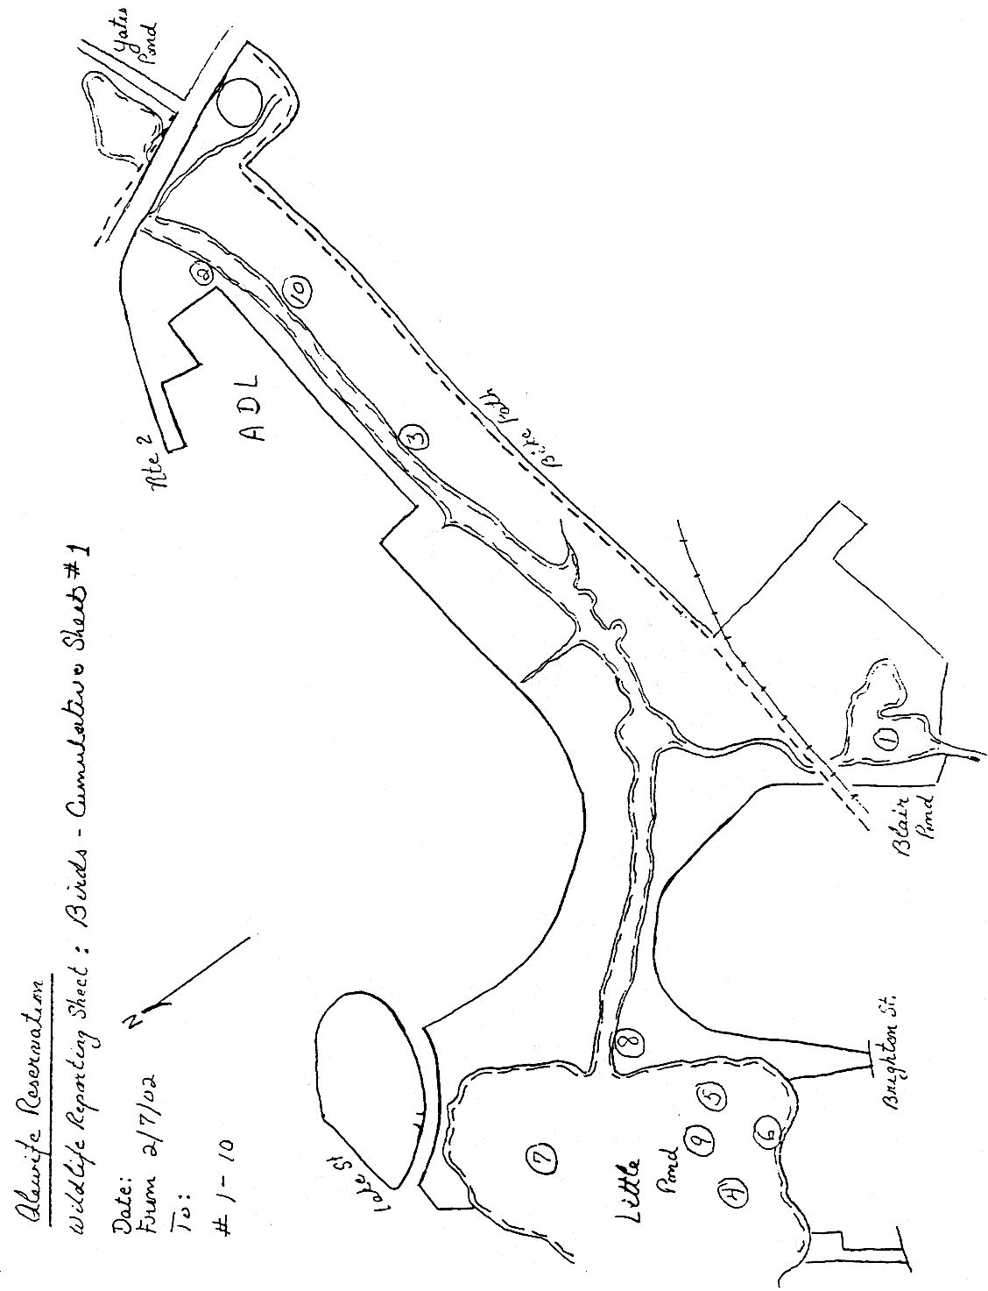
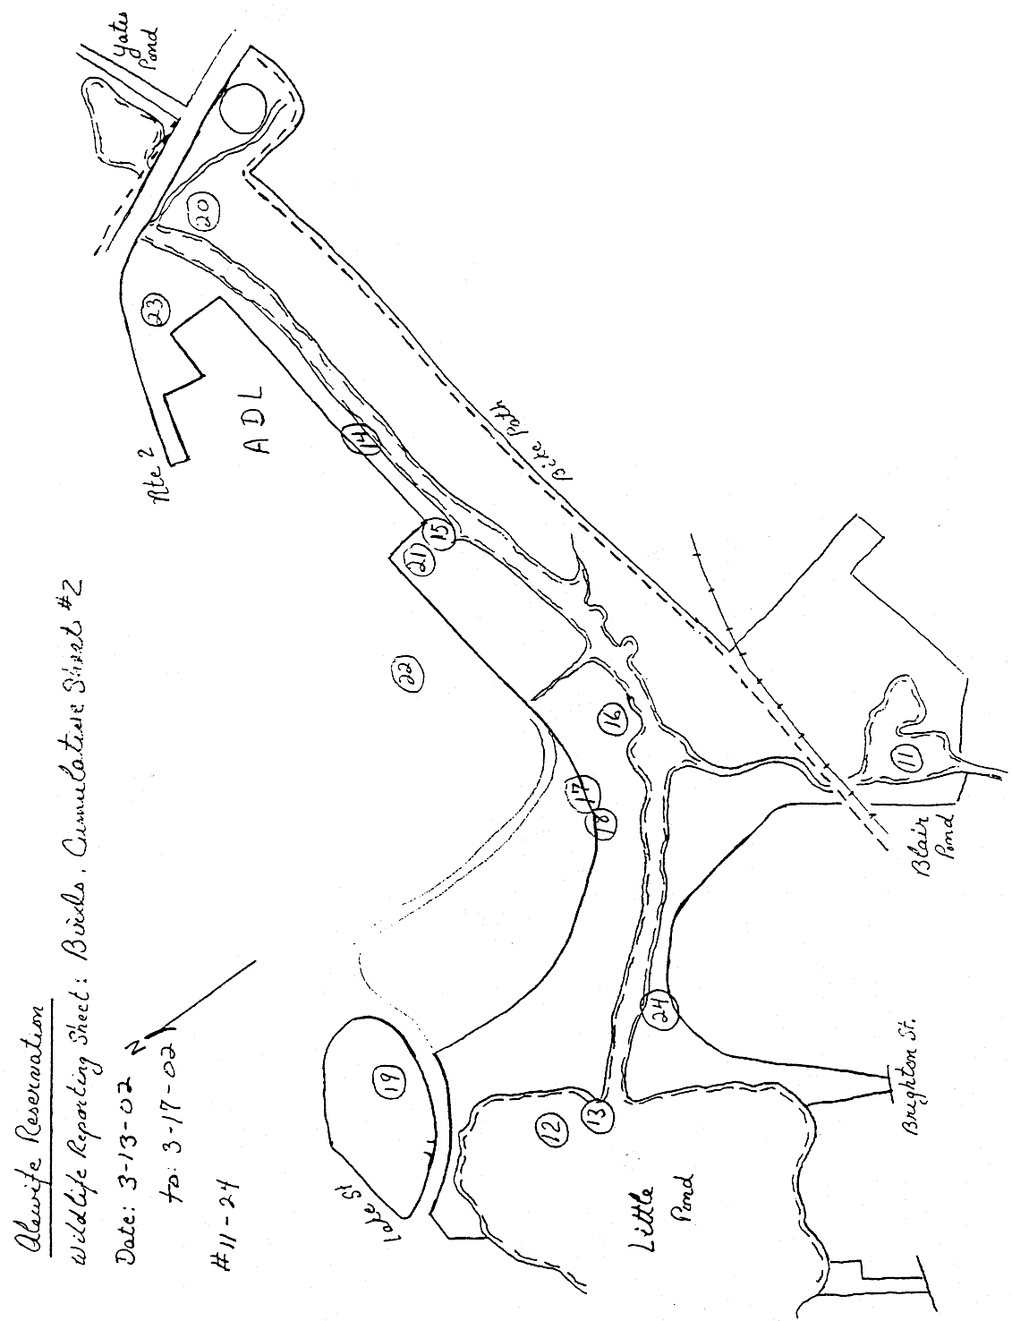
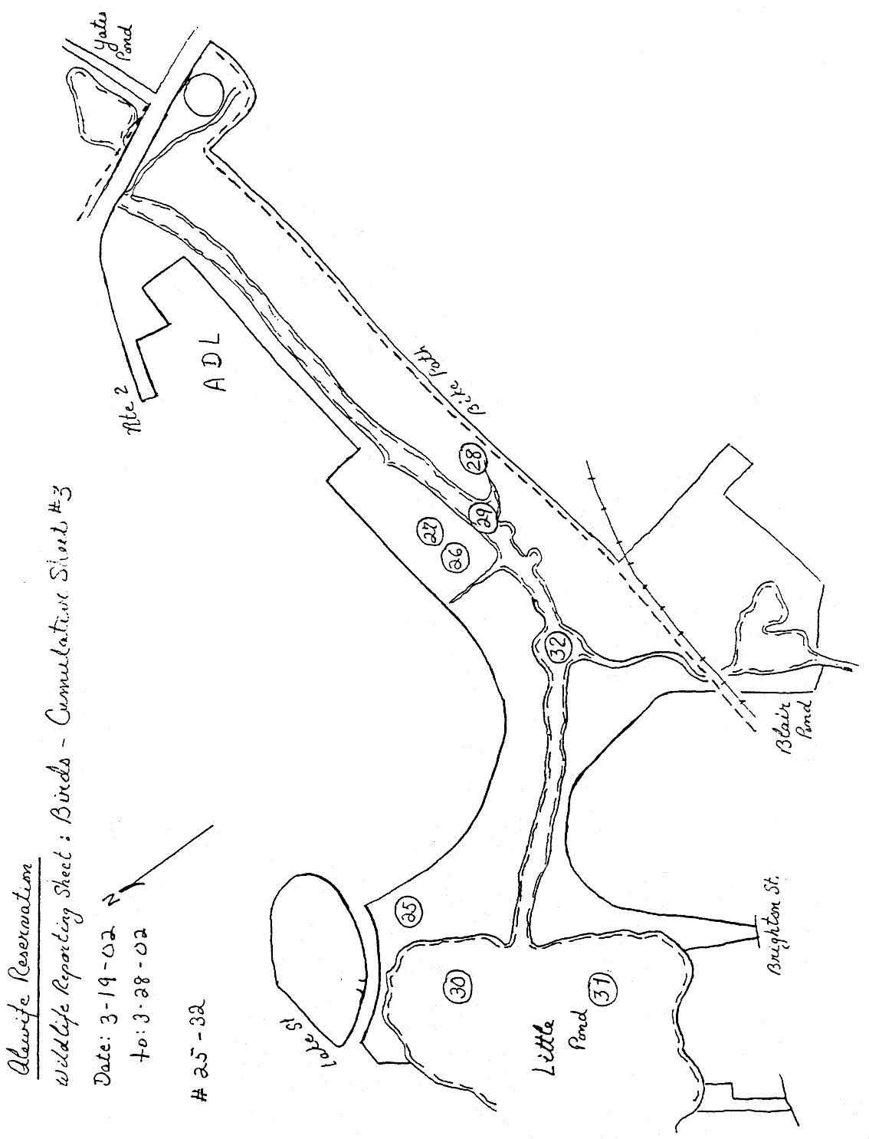
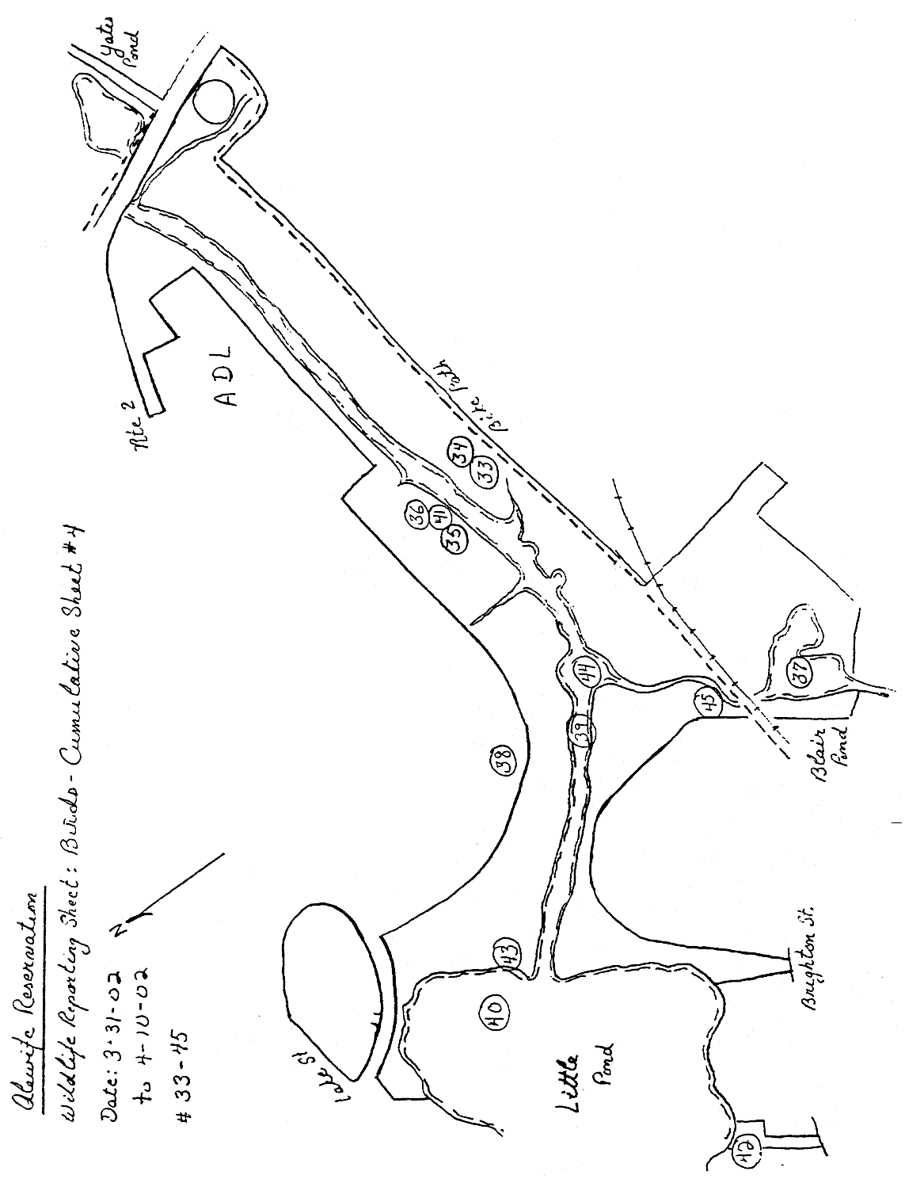
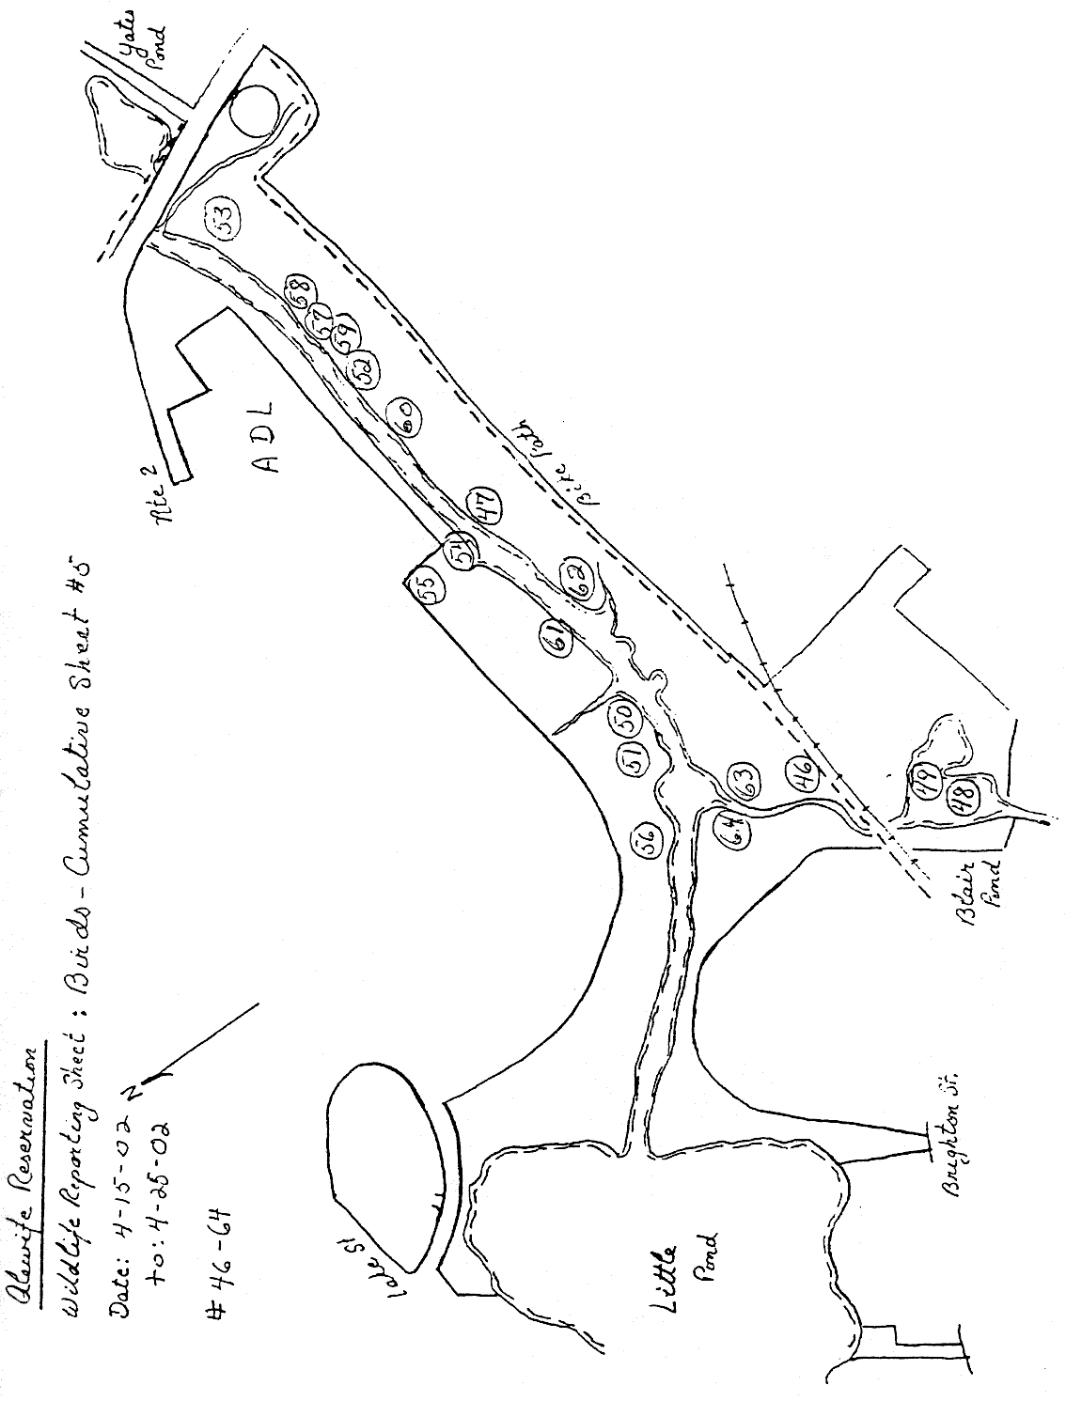
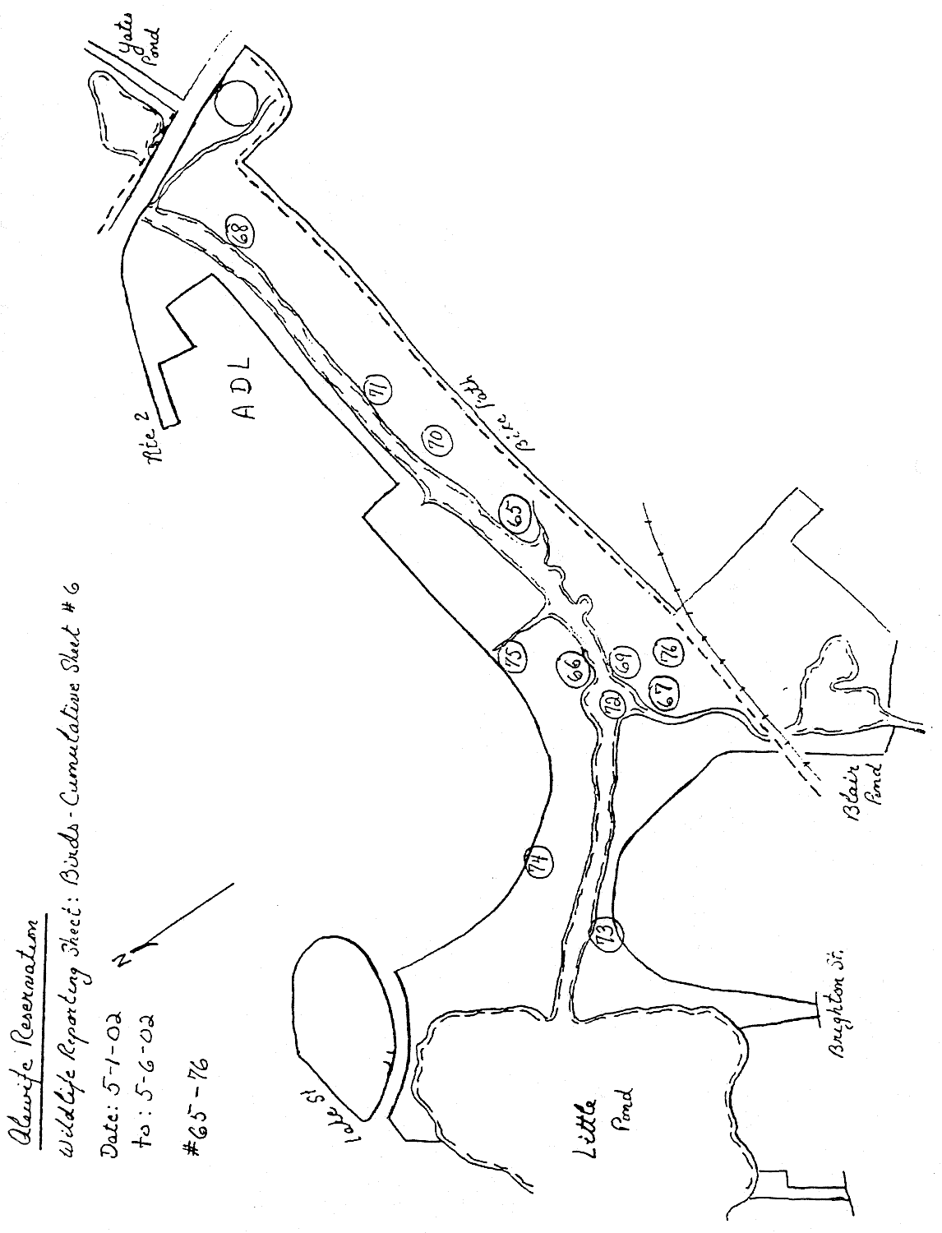
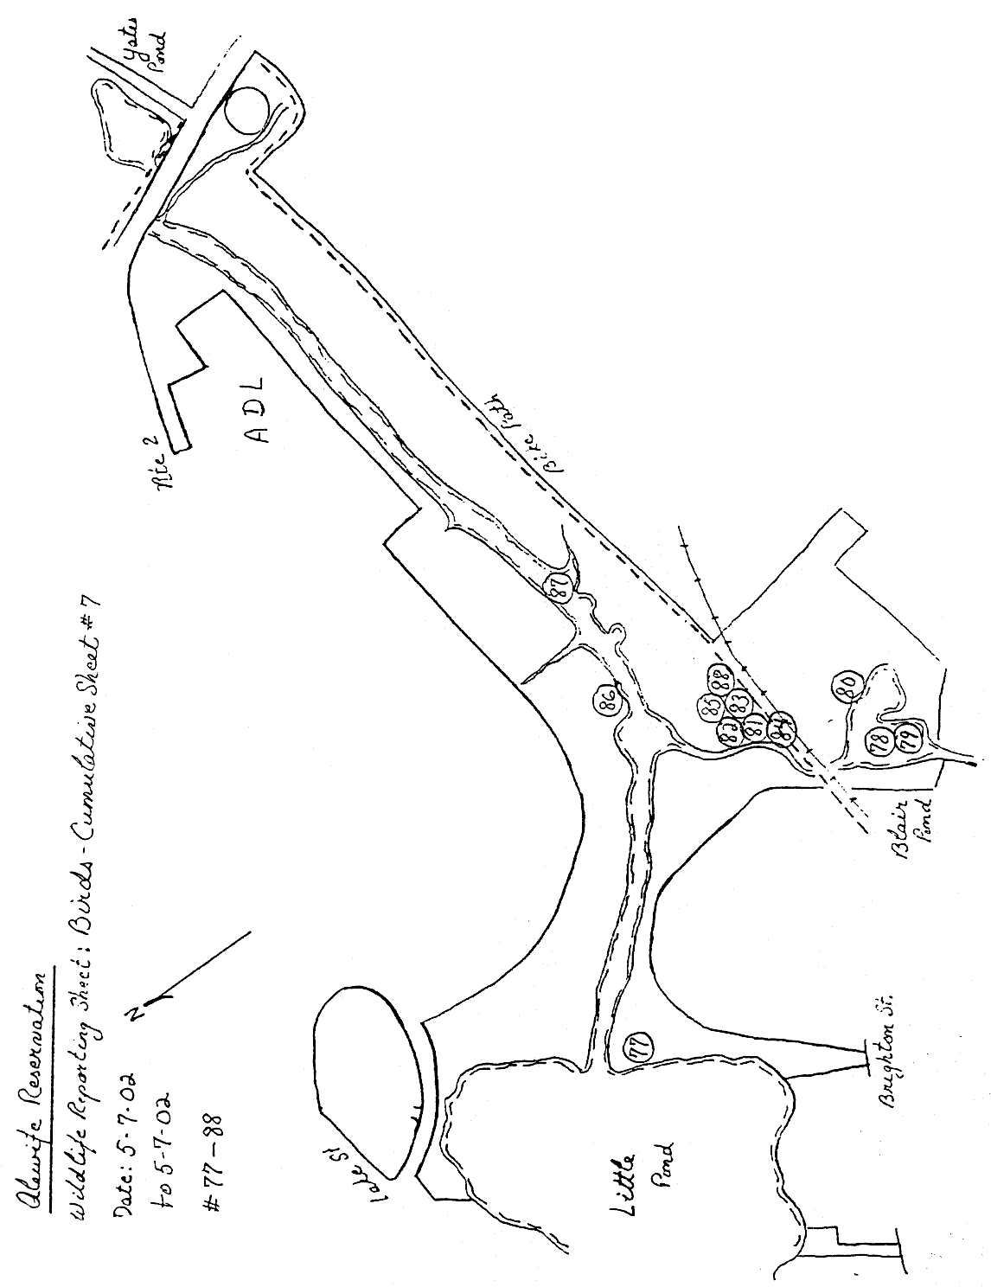
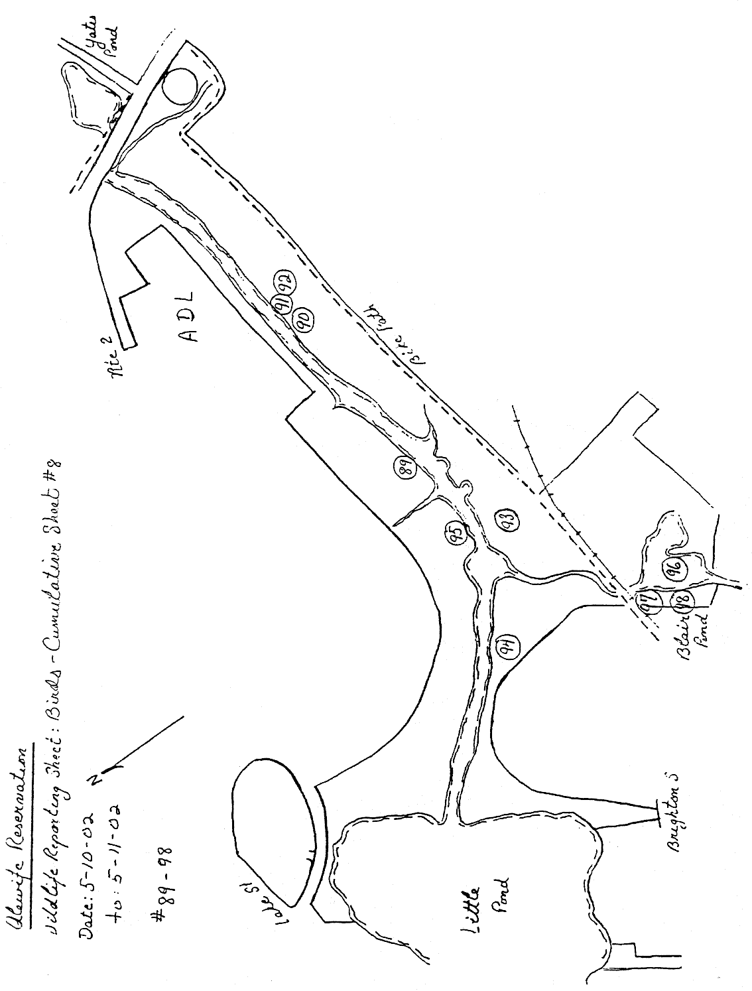
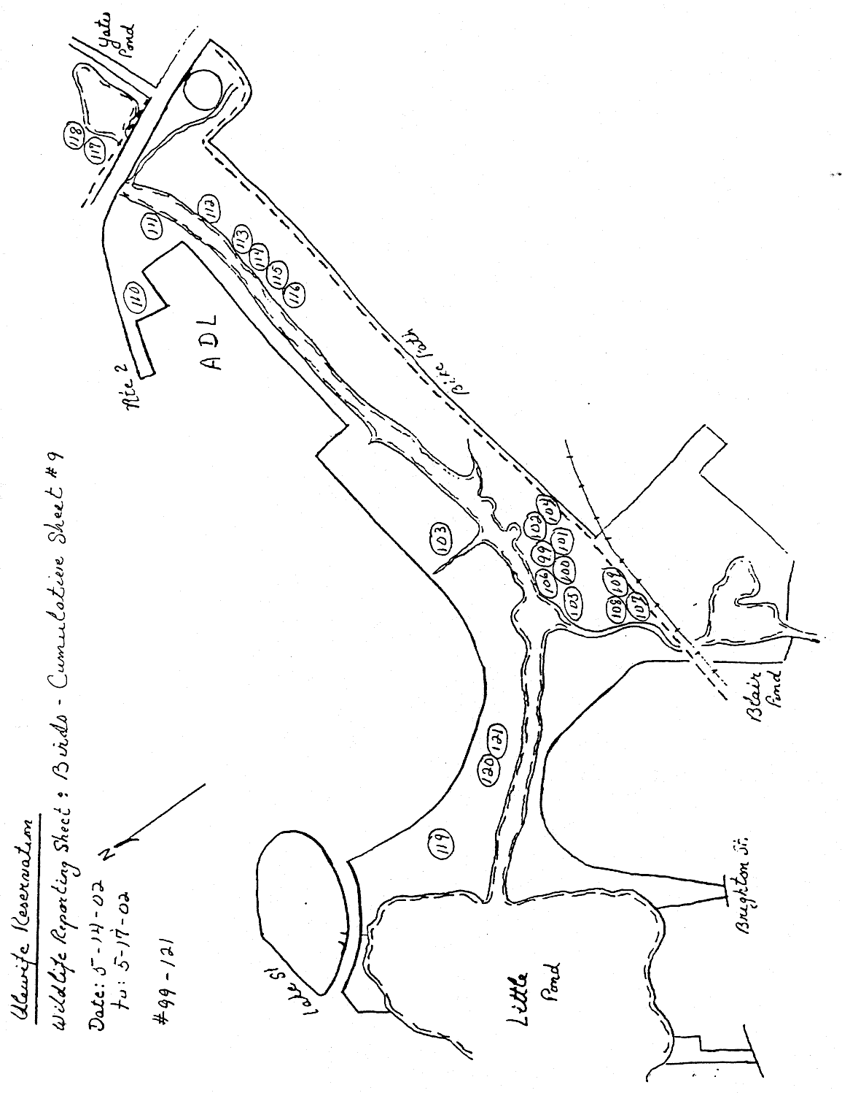
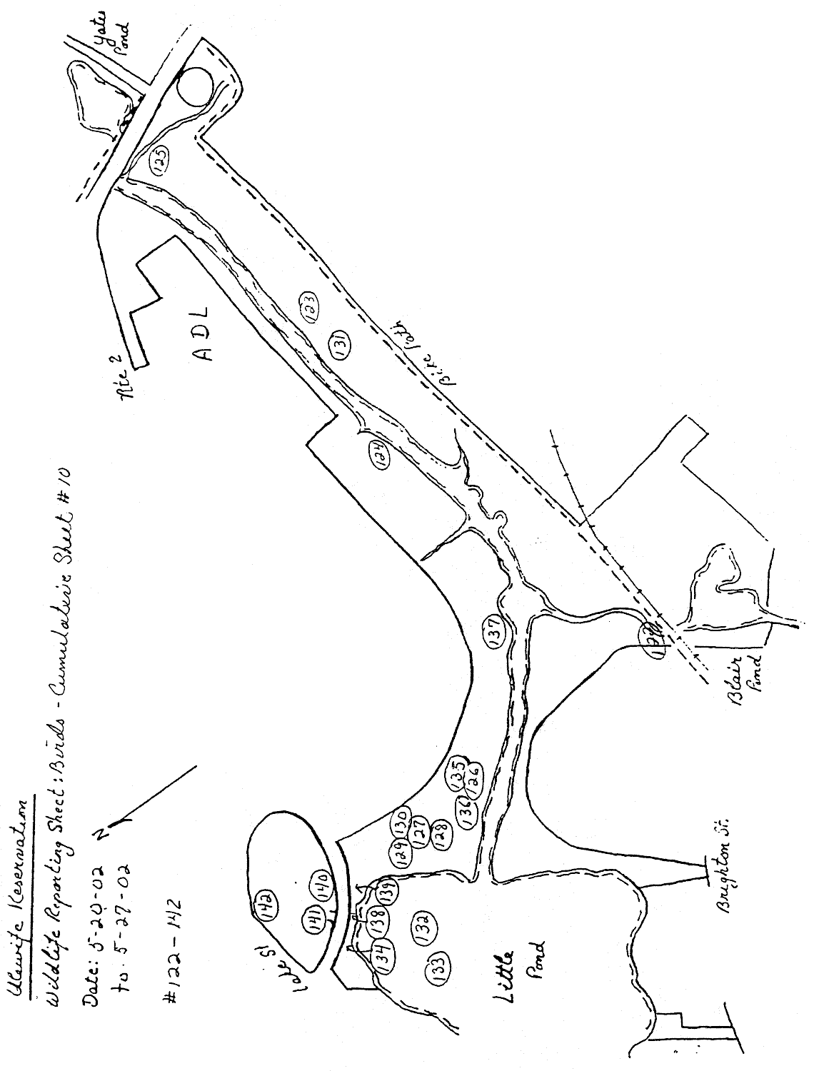
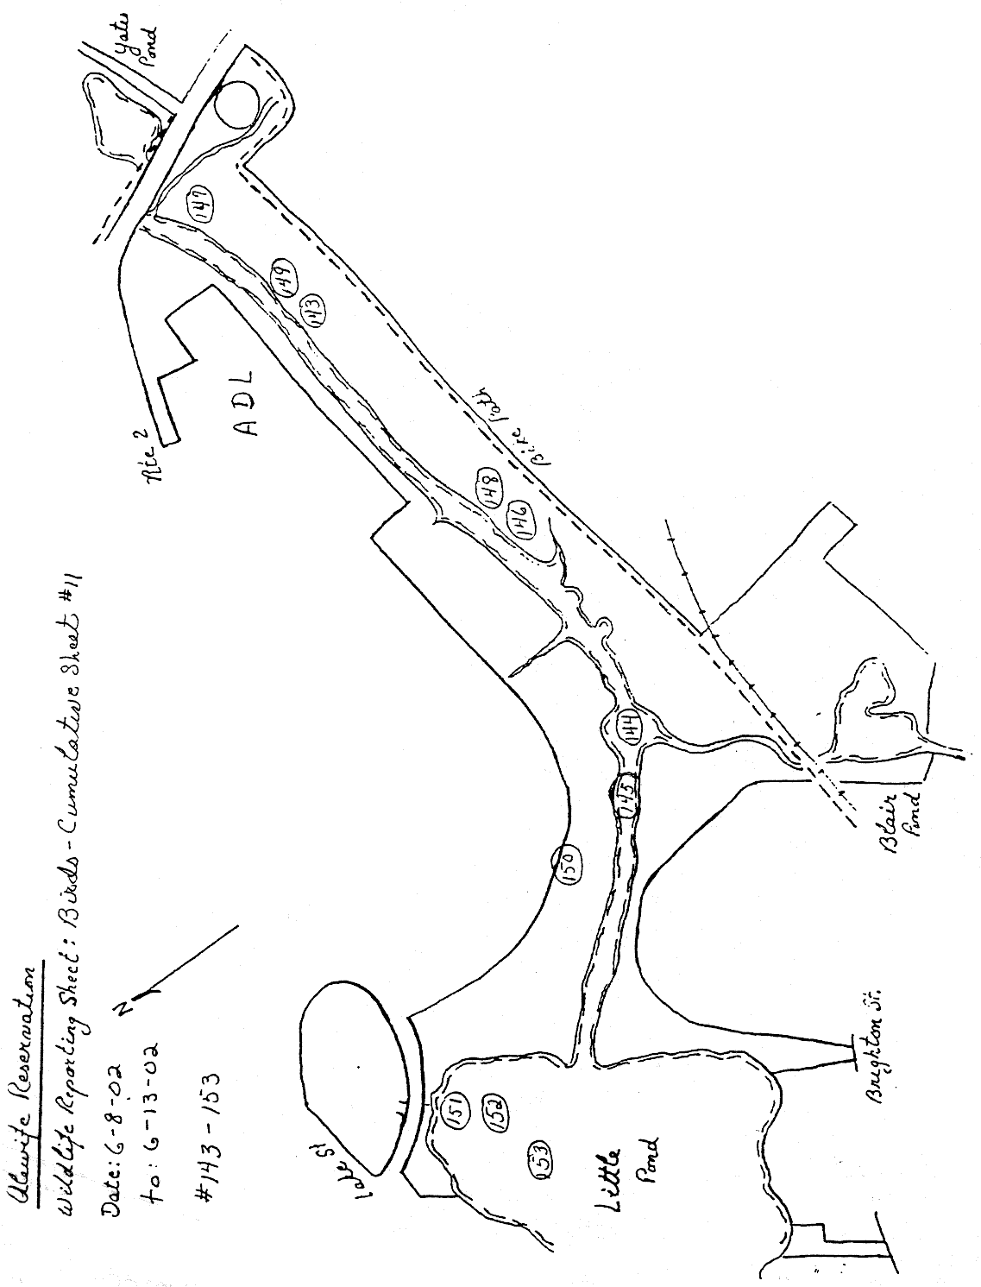

Appendix B: Interpretive Commentary
Alewife Reservation: Bird Survey-2002

(This appendix contains running commentary produced while the data in Appendix A was being collected. It does not represent the final evaluation on any of these species. See Discussion by Order in the body of the report for conclusions.)

General Comments
The Cumulative Observations database only contains records of the more unusual or otherwise significant species found during the census. Alewife Reservation contains the expected species of more common birds that one should find in late-winter, spring and early summer in an urban natural area. Common crows and bluejays are frequently sighted, as are black-capped chickadees and other common bark and twig gleaners that are resident in such parks. Flickers have been seen in the bottomland woods near Perch Pond and downy woodpeckers have been sighted in various trees in the park. Many robins appear to have been in the reservation all winter, feeding on the bountiful sumac berry crop. This species winters as far north as the White Mountains as long as there are berries and open water.
Catbirds inhabit the riverside brush all along the water system, and song sparrows are perhaps the most common bird in the reservation. Common grackles are indeed common throughout, as are starlings, an introduced species from England.
Many pairs of cardinals have been seen in the riverside and brookside brush. This species was rare and local in New England a few decades ago but has moved northward in response to a warming climate and/or the numerous bird feeders provided for seed-eating birds. In remote forested areas west of Rte. 495, outside of both the urban/suburban heat island and the concentration of bird feeders it remains an uncommon bird. In Alewife Reservation, however, it is frequently seen and adds a splash of color to the drab winter landscape.
Approximately 20 Canada geese frequent the ponds and the river. Of these only two pair were seen with young, a total of only five goslings having been counted during the survey. It is possible that, despite the appearance of having paired off, most of these birds are immatures that have ganged together awaiting sexual maturity. Nevertheless, the reproductive rate of the breeders is remarkably low. It is difficult to say whether this is a function of effective nest predation: two ravaged egg shells were found during the survey, or from some other factor, possibly environmental effects.

Numbered observations
(Numbers refer to the map charts and to the Cumulative Observations database. They are cross-referenced in all the tables in the body of the report.)

#1, 29. Two mated pairs of green-winged teal have been hanging out in Blair Pond for at least the latter half of the winter. These are surface feeders as opposed to divers and so need shallow water. Blair Pond provides this to a greater degree than nearby Fresh Pond, a traditional wintering area for many species of waterfowl.

#2. An immature red-tailed hawk regularly patrols the reservation, perching conspicuously in trees along its length. This species is a member of the buteo family of soaring hawks. Compared to true bird hawks, or accipiters, it is rather clumsy in the air and so birds are seldom captured. Small mammals such as voles, squirrels and even rabbits are its principal prey. All of these species are common to abundant in the park. Open country is best for this sort of hunting and the low vegetation along the river is ideal, since it provides good sight lines for the bird either perched in a tree or soaring overhead.

#3. A flock of twenty redpolls were feeding in riverside alders. This is a winter visitor from the north that only appears in numbers in Massachusetts during so-called “irruption years”, presumably years in which a poor seed crop in Canada forces these birds southward. Alder catkins, the winter seed structures that hang on alders like tiny Japanese lanterns are a staple for this species. Alder is a very common bush in northern bogs, but less common in the transition forest in central and southern New England. It grows along the river in Alewife and presumably its familiarity to these birds as a food source brought a flock of them to this grove in Cambridge.

#7, 12. These bizarre looking shoveller ducks breed in western North America. The birds in Little Pond are overwintering and can be expected to leave within the month.

#8, 13. Although only two entries in the database record observations of great blue herons, these birds have been seen regularly in Little River and especially at its outlet from Little Pond. In colder winters these birds winter at the coast where salt water doesn’t freeze. In this warm winter they have been hunting in unfrozen shallows in the park.

#14. Five white-throated sparrows were feeding in the vines that dominate the riverside brush behind ADL. This is a wintering species, attracted to Alewife Reservation by the seed-bearing brush that abounds at the edges of open areas. In fact the reservation is excellent for these and other sparrows, including the resident song sparrows that abound in the park.

#16. Flickers are a favorite prey for Cooper’s hawks, a large and secretive bird hawk. An adult display flight will be needed in April to confirm its presence.

#17. A smaller accipiter, the sharp-shinned hawk, flew into dense sumac near a woodcock lek at dusk. It was hunting and moved off northward after a few minutes. It was probably a migrant although most adults stay on expanded territory during the winter. Once again only a spring display flight will decide whether it si resident or migratory.

#18-26. The presence of woodcock in Alewife Reservation and its surrounding natural areas is well documented and know to local birders. These birds continue to thrive in the special habitat provided by the reservation. Since Stew Sanders’ Alewife Ecology Guide, published in 1994, however, there has been some shift in the location of leks, or male display areas. The two on or south of the bike path do not seem to contain displaying males at this writing. One, in fact, seems to be a new parking lot for an abutting office building. However, two sites not shown in 1994 are currently supporting singing males. One is in the field across Alewife Brook from the kiosk. The other is directly across the river and east of the ADL parking lot. Given the high density of house cat sign south of the river, it is doubtful that the displaying in the field behind the kiosk will result in successful reproduction. Woodcock are ground nesters, relying only on camouflaged plumage and a rudimentary nest to conceal their eggs.
At the moment I find at least five occupied leks in the park with one of these in the private holdings north of Acorn Park Drive and one near the property line between these holdings and the reservation. In all cases these leks are open grassy areas often with some shrubs in them or nearby. Woodcock males need flying room for their spiral ascent and twittering descent to the ground. They also need soft bottomland earth containing earthworms to feed. Both are supplied and in close proximity in Alewife Reservation.
Woodcocks are not listed as a species of concern in Massachusetts, but the decline in the number of grassy areas in the state has become a cause for concern as far as biodiversity is concerned. As fields revert to forest, species like bobolinks and woodcock decline. Development pressure for land has resulted in building in more and more marginal sites including bottomlands. As fields succeed to forest and bottomlands are built upon, important habitat for this species is lost.

#27, 28. Ring-necked pheasants are native to China and were introduced into North American by sportsmen and fish and game agencies. Their hoarse, resonant call was common at the edges of fields and in open bottomlands 20 years ago but has become increasingly scarce as succession and development have erased the fields. The presence of the species in Alewife and has been documented in the past and is a function of the bottomland brush adjacent to open spaces that characterizes much of the reservation.

#29. (Green-winged teal: See #1)

#31. Hooded mergansers spend the winter in the coastal estuaries, ready to move inland to fresh water as soon as they clear of ice. As this winter has been unusually warm, they have the luxury of overwintering on such inland ponds as have remained unfrozen. Mergansers are mainly fish eaters that nest in tree holes. As the eastern forest has rematured they have been increasingly able to find nest holes closer and closer to the metropolitan area. Eventually this beautiful little duck may nest in the metropolitan area.

#32. Wood ducks are often associated with hooded mergansers, occasionally raising each other’s offspring in cases where egg dumping has occurred across species. Since both species nest in natural cavities in old trees or in nest boxes and both use the same sort of water bodies, this occasionally happens. Unlike mergansers, which dive after fish, however, wood ducks are vegetarians and edge feeders, relying on emergent plants at the margins of ponds and streams for food.

#33. Red-winged blackbirds are one of the species that favor cattail marshes for nesting. In this case five males more or less circled a small marsh just south of the river, practice-displaying for females not yet arrived.

#34. Cowbirds are nest parasitizers, reproducing by placing their eggs in the nests of smaller birds where the hatchling outcompetes the host birds’ own offspring for food. They might more properly be called “buffalo birds”, since they apparently adopted the tactic of nest-parasitism so that they could continue a nomadic existence, following bison in the plains without having to return to a fixed nest. Given their heritage, they tend to favor open areas, of which there are many in the reservation.

#35. Merlins are small, fast-flying falcons whose nearest nesting area is in extreme northern New England and eastern Maine. This bird was clearly migrating northward, close to the ground where it could catch the small birds that are often its prey. A passing attack on an Alewife song sparrow was unsuccessful. Merlins mostly nest in open country and tend on migration to be attracted to areas that resemble their nesting habitat, such as the open fields and marshes of Alewife.

#39. Black-crowned night herons are migratory birds. This is the first returnee to the reservation, where its evening flights have been celebrated in literature for over a century. Like other herons, it feeds on fish, frogs and other aquatic invertebrates. The fish, at least, are forced near the surface around the outlet from Little Pond, where they can be preyed upon by both night herons and great blues.

#41. Hairy woodpeckers are larger versions of the familiar downy woodpecker, but with proportionately larger bills. They get their name from a ruff of feathers at the base of the bill. A common species 40 years ago, they have been reported to be in decline in recent times. This male landed in a riverside coppice maple and drilled insistently in one spot. After feeding it explored other trees close by and then flew away. Most woodpeckers are more or less non-migratory and so we can expect that this one is resident in the area.

#42. Carolina wrens are common birds south of New England. Like many other southern species, however, they have been extending their range northward and are now common on Cape Cod. Warm winters are usually accompanied by an increase in their numbers Boston northwards. Indeed, I found another one in Rowley a week or so ago. Their song, which resembles in quality that of a cardinal, is loud and arresting so that their presence can hardly be ignored. This one was in backyard shrubbery next to the MDC Winn Brook access track. This is favorite habitat for them and, of course, is slightly off-property. However, they also readily inhabit brushy natural areas, as well.

#45. Phoebes are flycatchers that perch prominently on outlooks and dart out at flying insects. Unlike the very similar wood pewee, phoebes continually twitch their tails, as if in agitation. They have the interesting habit of adapting to civilization by building their nests on man-made structures: under eaves or on the sides of buildings where there is enough of a ledge to hold the nest. This pair seems to be building on the culvert at Wellington Brook.

#48. Killdeer are classed taxonomically as “shorebirds” even though their preferred nesting habitat is disturbed sites showing dirt, pebbles and sparse vegetation. The stoniness of such sites conceals their speckled eggs, which are laid on the ground in the open and without nesting material. Disturbed sites are easy to find in Alewife. This pair were feeding on the exposed mud bar in Blair Pond.

#51. White-throated sparrows are native to the mountainsides of northern New England where their loud, clear song lends a lonely feel among the stunted, windblown spruce. Here they are winter visitors, feeding on seeds on winter-dried plants as do other sparrows. The abundant brush and herbage in Alewife apparently supplied enough of an attraction to keep this one around while its fellows have headed north.

#52. Palm warblers are often the first wood warblers to be seen in the spring. Their arrival is timed with first insect hatches. They are easy to identify, even in a distant overhead silhouette because they are the only wood warbler that twitches its tail. Palm warblers nest in extreme northern New England northward, usually in boreal bogs. Here they are migrants, and their presence in the canopy of aspens, a common successional tree along the Little River, is appropriate. Aspens are a northern species themselves, that must leaf out in the spring as early as possible to take advantage of the limited growing season in boreal regions. In so doing, they often host an early insect hatch that, in this case, attracted a burst of migrating insectivorous warblers.

#53. Ring-necked pheasants appear to me more common now than when Stew Sanders wrote the current ecology guide in 1992. I have heard calling birds in widely separate parts of the reservation and believe there are at least three males present at the moment. As these birds are non-migratory, it is safe to assume that they are residents. The numbers of this species have been in decline in Massachusetts for many years, partly due to the loss of open brushy natural areas that have either grown up to forest or to houses. Alewife has plenty of treeless, brushy habitat with the kind of dense cover favored by this introduced species.

#54. Yellow-rumped warblers (nee “myrtle warblers”) are early migrants that winter just to the south, and occasionally just north of Boston. Their nesting range begins around the New Hampshire line. Unlike most warblers they are habitat generalists, feeding at all levels of the forest. As a result they tend to be abundant and perhaps the most frequently seen spring warbler. This was the first bird of the species that I have found in the reservation this spring.

#60. Carolina wren: Unlike the other bird (see #42), this bird was skulking in streamside bushes well within the reservation. The fact that it was singing at a location, a half mile from the other sighting suggests that it may be a different male.

#65. Black-throated green warbler: This bird landed momentarily in a riverside bush in the early morning, before taking off again, heading north. This is the first of this species recorded in the survey. These birds favor dense conifers, few of which occur in Alewife, and, therefore, is unlikely to nest.

#69. Warbling vireo: This bird was singing and feeding in an apple tree on the bank of Perch Pond. It is the first of this species found in the survey. Alewife is within its nesting range.

#71. Carolina wren: This is probably the same male that was found here in entry #60. Its persistence at the site indicates a likely breeding attempt. However, as this species is relatively new locally and therefore scarce even in good habitat, it is uncertain whether it will be able to attract a mate.

#72, 78. Solitary sandpiper: These birds are migratory; their nesting range is in the northwestern part of North America. They were clearly attracted by the exposed mud bars both in Perch Pond and Blair Pond, which provide them with a migratory stopover.

#73, 74. Northern parula: These are the first of these wood warblers recorded in the survey. On migration they favor deciduous tree canopies. On their breeding grounds, they nest in hanging epiphytes like “Old Man’s Beard” that festoon northern conifers as well, occasionally, in flood debris caught in tree branches over rivers. It is possible, but unlikely, that they will try to nest in Alewife, both because of the lack of conifers and lack of flooding in the channelized Little River.

#75, 84. Common yellowthroat: This tiny, masked wood warbler nests in brushy wet areas. As there is a great deal of this type of habitat in Alewife, it probable that members of this species will nest. These are its first occurrences during the survey.

#76. Baltimore oriole: This is the first record of this species during the survey. This bird favors large shade trees, often feeds in blossoming apple trees, and nests in trees with hanging branches, such as the weeping willows. All these requirements are at the west end of the reservation on Little Pond and around Hill Estates.

#78. (Solitary sandpiper: See #72)

#81. Northern waterthrush: These wood warblers feed and nest typically in boggy bottomlands near water. This is the first record during the survey. Whether it will persist at the site will have to be checked in June.

#82. Black-throated blue warbler: This was another fresh migrant, found in the same “warbler hollow” next to Wellington Brook as the waterthrush above and several other warblers below.

#84. (Common yellowthroat: See #75)

#85. Ruby-crowned kinglet: This is a so-called “old world warbler” that generally nests north of our region, migrating through mostly in April. It is the first of the species recorded in the survey and is probably a late migrant.

#86. House wren: Two of these birds were consorting yesterday along the bike path and slightly off-property. This signing male, however, was on the north bank of the river near Perch Pond.

#95. White-eyed vireo: This is one of those species, like the Carolina wren, that has been slowly extending its range northward in the last decade. It is still an uncommon species at this latitude. Two song utterances were heard from some distance away, across the river. However the bird has a very distinct song and the habitat in which it was heard matches its nesting and feeding preference, specifically, brushy areas with blackberry brambles.

#115. Prairie warbler: This is the first occurrence of this species during the survey. It name is misleading as its favorite habitat is dense growth, often in birch scrub following a burn or under powerlines. Two birds were seen, one following the other from above as it fed in dense ground cover in the open area of brambles just east of the large aspen grove. This area matches the bird’s habitat preference well enough that a check will be made later to see if the pair has stayed to nest.

#119. Wood thrush: Wood thrushes have been in a general decline in eastern Massachusetts. This one was singing in the dense silver maple floodplain west of Acorn Park Drive. Its continued presence will be checked later.

#122. This female redstart was calling repeatedly from the trees between the bikepath and Hill Estates. Given the number of males in the vicinity, this behavior may result in nesting.

#124, 125. Two singing male willow flycatchers appeared simultaneously, the first of the spring. They will be checked later, given the reports of a nesting pair previously in the vicinity.

#126, 135. This Canada warbler was another new appearance in the park for this spring. It was singing in the lower part of the canopy of a large deciduous tree next to a small clearing that has attracted other warblers recently: black-throated blue and parula, neither of which were detected on this visit and were presumably migrants.
A week later a Canada warbler was again detected in the same area, probably the same individual and so possibly establishing breeding territory.

#126-130. Although all the species listed have been found elsewhere, they were recorded here to suggest their distribution and to point to this area. A shoreline marsh rises to a small blackberry clearing, bordered by a grove of black cherry trees with an understory and brushy edge growth. The overlap of several habitats resulted in a concentration of sightings in the vicinity.

#131. A male indigo bunting was singing in the aspens bordering an open area. This is preferred habitat for this species and so its presence will be checked again after migration.

#133. A pair of mute swans were floating on the pond, preening. Possible the same pair were seen a month ago flying high over mid-river. Mute swans are an alien species originally kept on European, and later American estates. Feral escapes began spreading into our region several decades ago and have nested successfully. They are generally regarded as a harmful species because, with their long necks they can root out aquatic vegetation at depths unavailable to native waterfowl and so ruin habitat for them. They also have a reputation for behaving aggressively toward other waterfowl in their nesting area. For both these reasons they tend to displace native ducks, a tendency frowned upon by Fish and Game departments, which have tried a number of tactics to discourage nesting.

#134. Blackpoll warblers nest in the boreal forests of the north, with their southernmost breeding area being the spruce-fir slopes of the White Mountains. They are fairly late migrants with a weak song and rather dull, black and white plumage. In the increasingly dense foliage of late spring, they are often overlooked on migration or taken for chickadees. This bird was singing and feeding in a black cherry that grows in a narrow border of dense trees, vines and brush along the north shore of Little Pond, between the pond and busy Frontage Road. This was the first occurrence of this species in the inventory.

#135. (Canada warbler: See #126)

#139. Best know for their habit in the other three seasons of feeding in flocks on berries, cedar waxwings in spring and early summer must feed on other things. In early spring they eat blossoms of flowering trees and as the season progresses into summer they become very good flycatchers, often congregating near water to take advantage of hatches of flying insects.

#140-142. The birds listed are found commonly elsewhere in the reservation but are listed here to draw attention to the site of a former skating rink that has been allowed to revert to the wild. Presently it is a large field bordered on two sides by brush and trees. Because the site is fenced, human and pet intrusion appears to be minimal, although pets, at least, could enter through a generous gap in the gate. A walk around the perimeter revealed the presence not only of the listed birds but also red-winged blackbirds, goldfinches, mourning doves, starlings (already with fledged young), catbirds, robins and song sparrows. Earlier in the spring a displaying male woodcock was heard in the field.

#143. Several red-eyed vireos were feeding in a riverside tree. One was continually singing. This is the first occurrence for this species in the survey. The presence of three suggests they are late migrants, perhaps one-year olds not breeding.

#144. Probably the same pair of mute swans that were seen in #133 were cruising upriver. They do not seem to be attending a nest, and so, like many of the paired Canada geese in the same habitats, they may be non-breeding immatures.

#145. Two wood ducks were flying downriver, low. By the time I got them in the binoculars, I could only assure myself that one was a male. Whether this is a mated pair, possibly nesting on the reservation will be watched for. There have not been any sightings of wood ducks since early spring migration.

#146-7. These are certainly the same two willow flycatchers from May 20, still in place nearly three weeks later. This undoubtedly qualifies as an attempt to breed.

#149. A single male red-eyed vireo was singing in a riverside tree in the same area as several birds two days ago. This revises its status to uncommon breeder. Another bird was heard singing in roadside Norway maples on Acorn Park Drive later in the morning.

#150. Although the singing male Carolina wren found at mid-river in the past has been silent lately or has moved on, another (or the same) was detected singing briefly in the Belmont uplands. The continual presence of this species in or near the park throughout the spring dictates its status as uncommon breeder.

#151. A male and female wood duck swam away from the shore at my appearance. These are probably the same pair glimpsed in #145. Although they were clearly a mated pair, there were no ducklings. Since offspring should be visibly present by now, these birds are probably unsuccessful breeders on the reservation.
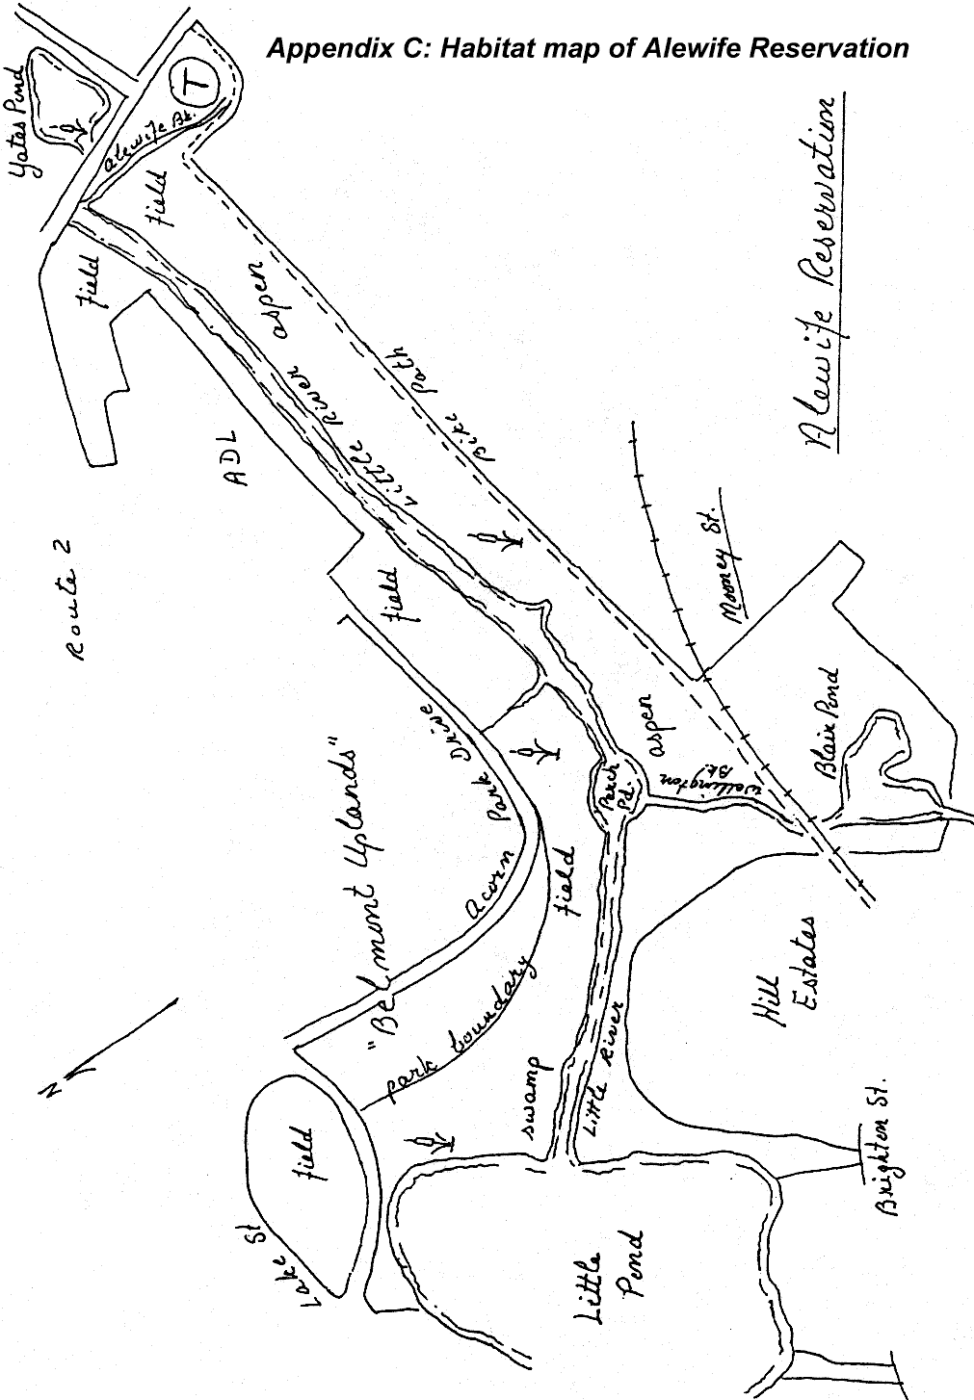

Appendix D: Cavity Users

The list below shows native birds found in eastern Massachusetts, past, present or future, that either use or require the presence of cavities either in standing deadwood or mature live trees. The cavities may be the result of the work of the birds themselves or may result from limbs dropping off old trees, creating access to the hollow interior. The use by birds may be for nesting or roosting.

House sparrows and starlings, both alien species imported from England, nest in cavities as well. Both are early and aggressive nesters that deny cavities to native birds and, in the case of house sparrows, may pierce the eggs of other cavity nesters in the area. The decline in bluebird populations as well as the recession of red-headed woodpeckers from New England are commonly cited as examples of the effects of these two alien species.

Require:
- Wood duck
- Common merganser
- Hooded merganser
- Kestrel
- Barred owl
- Screech owl
- Saw-whet owl
- Common flicker
- Downy woodpecker
- Hairy woodpecker
- Red-headed woodpecker
- Red-bellied woodpecker
- Pileated woodpecker
- Great crested flycatcher
- Tree swallow
- Tufted titmouse
- Black-capped chickadee
- White-breasted nuthatch
- Red-breasted nuthatch
- House wren
- Winter wren
- Carolina wren
- Bluebird
- House finch

Use:
- Turkey vulture
- Barn owl
- Common grackle
- Eastern kingbird

Appendix E: Nest boxes

As has been noted in the body of the report, Alewife has a scarcity of natural cavities available to hole-nesting birds. Except for a few old black willows, most of the trees in the park are too young to have lost limbs due to age or to have acquired soft core wood of the sort that would induce woodpeckers to bore an initial hole that then could be used in the future by other birds. Appendix D lists the species of birds that either use or depend on cavities for nesting and roosting. Some of these are species whose presence on the reservation might be regarded as desirable and for whom otherwise suitable habitat exists. There appears to be enough open marsh and grassland to accommodate kestrels, the smallest of the native falcons; open woods with nearby fields is the perfect habitat for screech owls; low-edge shoreline, mainly at Little Pond, provides at least some habitat for wood ducks, although the channeling of the river eliminated much emergent vegetation upon which this species depends.

Although it may seem like a simple thing to knock a few boards together, bore a hole and put up a nest box, it actually requires careful planning, construction, siting, monitoring and maintenance if it is to serve as useful addition to the nest-cavity space available in Alewife. Unless all these aspects are attended to, the box may either go unused, or worse, may serve as an unfortunate attraction to nest predators as well as to the cavity nesting birds, creating unnatural, human-assisted predation.

Nest boxes should be put up in the fall for use the following spring. This will allow the wood to weather, making the box less conspicuous to predators. It will also cause the scent of both the freshly cut wood and the builder to dissipate from the box itself as well as from the access route used for its erection. Some nest predators like raccoons associate human scent with food and may follow a human trail to a nest box.

Predator guards can be added to the support and/or to the hole in the box. These can be a sheet of metal nailed around the support to prevent mammals and snakes from climbing up to the box. A tube or broad lip can be added to the outside of the hole to create a stretch for a raccoon attempting to reach inside. Note that, for the same reason, it is very important that the box have enough depth. Otherwise, nesting material added to the box may raise the level of the eggs or nestlings to within reach.

An individual or committee needs to be available to check on the boxes regularly during breeding season, as well as to clean them afterwards. In the event that the box is taken over by a noxious alien species like house sparrows or starlings, the monitors must be willing to open the box and destroy the nest, perhaps repeatedly, or destroy the incubating bird itself. If the Friends group is unwilling to do this, the boxes should not be erected in the first place, as their availability will lead to a larger population of these destructive species and a consequent reduction in native species with whom they compete.

The information below on bird houses for three desirable species is adapted from the “Public Service Information: Birdhouses” bulletin, produced by the Massachusetts Audubon Society. It is recommended that a complete copy of this publication be acquired from that organization.

Kestrel box:

Design
Inside dimensions: 8X8X16” high.
Hole: 3” in diameter, 13”above floor (inside)
Add 3” of wood chips.

Placement:
10-30’ high next to open grassy or marshy area.

Screech owl box:

Design:

Inside dimensions and hole: same as for kestrel. Add 3” of wood chips.

Placement:
10-30’ high in wooded edge of field.

Wood duck box:

Design:
Inside dimensions: 12X12X22” high
Hole: 4” in diameter, 17” above floor (inside).
Add 3” of wood chips and ladder to inside. This “ladder” is a series of grooves milled into the interior of the box below the hole to assist in the ducklings’ exit from the box.

Placement:
5’ over open water or beaver impoundments; 15’ over ground in wooded swamps, or bottomland near open water.
Do not erect wood duck boxes within sight of one another!

