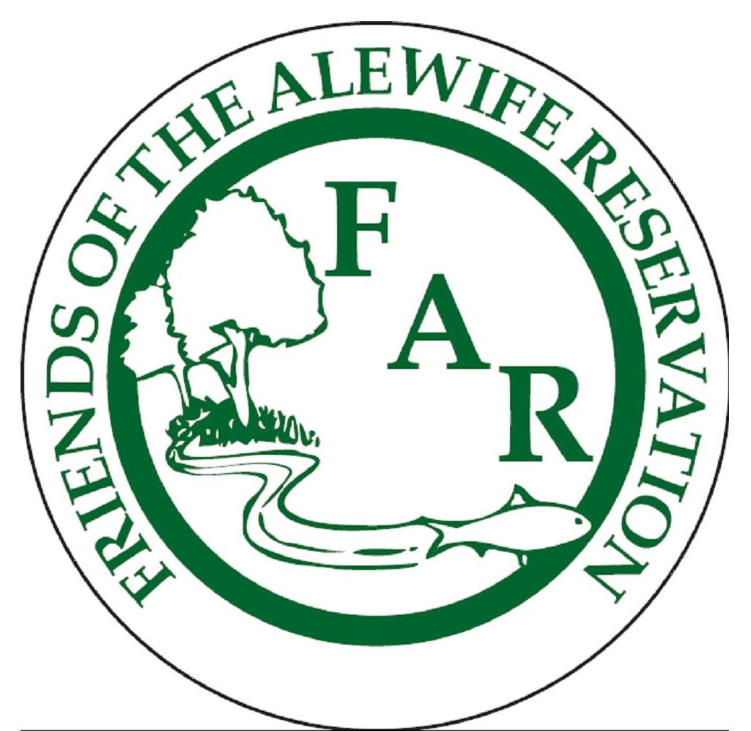 | Friends of Alewife Reservation  Protecting Boston’s last wilderness  www.friendsofalewifereservation.org
We are on Facebook! Click here to “like” us on Facebook and receive updates about the Alewife Reservation.  Online donations now possible!  Visit Wainwright Bank’s Community Room to make a secure donation to Friends of Alewife. Thank you for supporting our work!  Friends of Alewife Reservation is a 501(c)3 non-profit.  186 Alewife Brook Parkway, Suite 304, Cambridge, MA 02138  Phone: 617 415-1884  info@friendsofalewifereservation.org  Residents of Belmont have joined civil forces to help promote conservation of the Belmont Uplands. Please support your neighbors’ efforts to protect our last urban wild by visiting their new website atwww.belmontcoalition.org and making a donation as well spreading the word. You can "like" them on Facebook and share the link with Friends. | Silver Maple Forest Goes to Trial  On March 2, 2011 Middlesex Superior Court, Justice S. Jane Haggerty presiding, held a Hearing on Plaintiffs’ Motions for Judgment on the Pleadings. Attorneys representing the Plaintiffs Coalition to Preserve the Belmont Uplands, Winn Brook Neighborhood Association, Friends of Alewife Reservation and more than 10 residents of Belmont and Plaintiff Belmont Conservation Commission requested the Court to vacate the decision of the DEP Commissioner. They alleged decision will cause significant environmental harm to the Belmont Uplands, Alewife Reservation and surrounding residential areas by allowing the construction of a large housing complex by ONeil Propereties.  Plaintiffs argued that the DEP’s decision to allow the project was based on unlawful procedures and errors of law. Read full coverage of appeal at Wicked Local Cambridge.  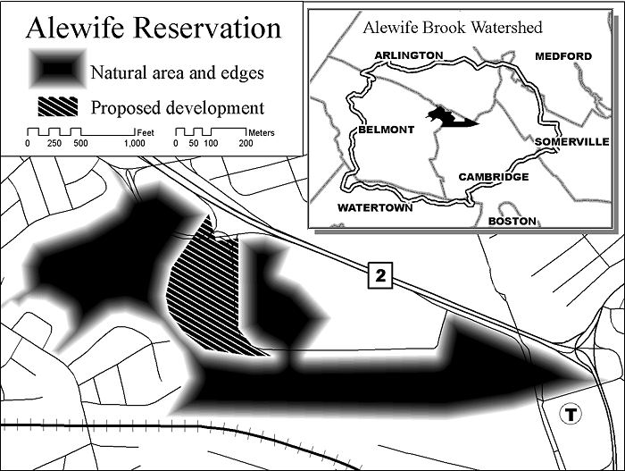  Map of Alewife Reservation    Red Tail Hawks “Buzz” Ruby who have become local celebrities with residents, ensure the cycle of life continues at the Alewife Reservation.  A Civil Action  Friends of Alewife Reservation presented 1000 plus signatures to Representatives, Wolf, Brownsberger, Garbally, and Senators Donnolly and Jehlen March. Signers of the petition urge legislatures to be vigilant with further actions to prevent the valuable floodplain and floodplain forest from destruction and incursion.  Afterwards, the delegation visited Bob O'Connor of the Executive Office of Environmental Affairs who accepted the 1000 petitions for the Agency and welcomed floodplain map, property designations, and he explained that the EOEEA would be evaluating the property soon.  Delegates explained to the legislators and EOEEA that an alliance was forming between Belmont, Cambridge and Arlington, made up of citizens  who cut across town and city borders to address the dangerous regional impacts of removing a small river floodplain forest and allowing an expansion of building in the area without addressing the serious problems plagued by the alewife watershed that continues to see bacteria counts rise and flood waters threaten residents’ homes.  Friends of Alewife Reservation Petition to Save the Silver Maple Forest.
  Read Ben Proffer on the Silver Maple Forest Trial, Change.org contributor, Sherman’s Travel and New York Magazines.
EVENTS:  16th Annual Mystic River Spring Cleanup  For the beauty and health of our river!  When:Saturday, April 30, 2011  Time: 9:30 am to 2pm  Supplies and refreshments provided. Call 7781-391-2604 with questions. (Rain date: suday, May 1, 2011.)  Mystic River Herring Run and Paddle  Run, Walk or Paddle for the fish!  When: Sunday, May 15, 2011:  http://mysticriver.org/herring-run/ for details, to register and for volunteer opportunities.  2010 Vernal Equinox observance at Alewife Reservation.  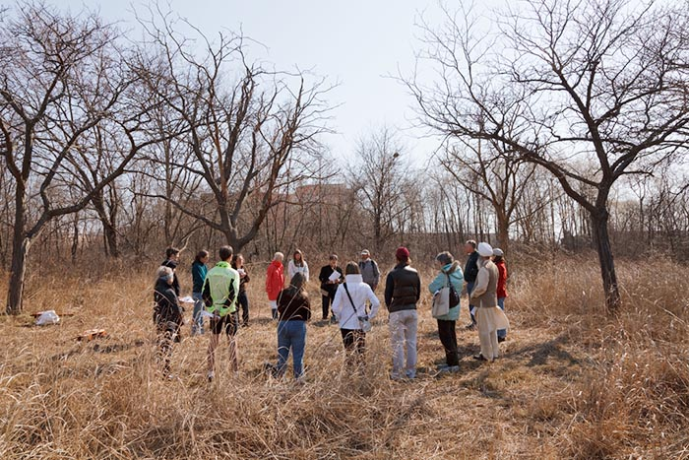  Wildlife Walk series  Next: April 16  1:00, Led by local  naturalist. Signs of  Alewife Reservation  Flora and fauna will  Be found and studied.  617 415-1884 for info. | Worst Case Scenario Facing Forest and Floodplain  Ellen Mass  The forest is direly threatened at this time. Your support is needed. Calls to Belmont officials are required to delay a land clearing permit. We hope there is interest in a rally from all of our readers to secure protected conservation land from our valuable and beautiful open spaces. The FAR 5 minute video traces some of the history and highlights of regional efforts (Cambridge, Belmont and Arlington) community to protect the silver maple forest and the vital floodplain for these communities and downstream towns and cities of the Mystic River watershed and the Boston Harbor.  silver maple forest video  Most of our constituents and citizenry abhor empire building and cheap land purchases on the Mystic River watershed for personal gain and without community considerations and without Wetlands Protection Act enforcement, and absent of a fair DEP state hearing in 2009. When requesting this fairness at Woburn Superior Court by Plaintiff attorneys, the Attorney General’s office virtually represented the developer and the DEP against the conservationists. We hope that Judge Haggerty will take into account all of the noted professional witnesses, testimonies and cross-examiniations that were omitted from the final DEP decision against the plaintiffs and Belmont Conservation Commission, and that the negative DEP Decision will be stricken fm the record and remanded to the appropriate state or municipal agency for review.  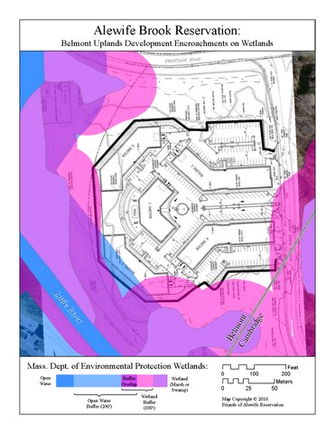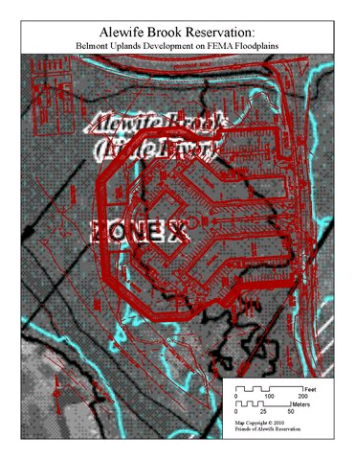  O'Neil Development Footprint on Federal Emergency Management Agency (FEMA) 2010 Floodplain Map on forest area. For more information on maps: FEMA 2006 Floodplain Map. (Scroll to see all maps.) GIS mapper: Dan Morse

